**ISO 19159-4:2020 (X)**

ISO TC 211/SC ##/WG 6

Secretariat: SN

Geographic information – Calibration and validation of remote sensing imagery sensors and data– Part 4: Space-borne Microwave Radiometers

DTS stage

**Warning for WDs and CDs**

This document is not an ISO International Standard. It is distributed for review and comment. It is subject to change without notice and may not be referred to as an International Technical Specification.

Recipients of this draft are invited to submit, with their comments, notification of any relevant patent rights of which they are aware and to provide supporting documentation.

*To help you, this guide on writing standards was produced by the ISO/TMB and is available at* [*https://www.iso.org/iso/how-to-write-standards.pdf*](https://www.iso.org/iso/how-to-write-standards.pdf)

*A model manuscript of a draft International Standard (known as “The Rice Model”) is available at* [*https://www.iso.org/iso/model_document-rice_model.pdf*](https://www.iso.org/iso/model_document-rice_model.pdf)

© ISO 2020

All rights reserved. Unless otherwise specified, or required in the context of its implementation, no part of this publication may be reproduced or utilized otherwise in any form or by any means, electronic or mechanical, including photocopying, or posting on the internet or an intranet, without prior written permission. Permission can be requested from either ISO at the address below or ISO’s member body in the country of the requester.

ISO copyright office

CP 401 • Ch. de Blandonnet 8

CH-1214 Vernier, Geneva

Phone: +41 22 749 01 11

Fax: +41 22 749 09 47

Email: copyright@iso.org

Website: www.iso.org

Published in Switzerland

Contents

Foreword iv

Introduction v

1 Scope 1

2 Normative references 1

3 Terms and Definition 1

4 Symbols and abbreviated terms 11

4.1 Abbreviated terms 11

4.2 Symbols 12

4.3 Conventions 12

5 Conformance 13

6 Notation 13

6.1 UML notation 13

6.2 Identifiers 13

7 General microwave radiometer sensor calibration and validation model 14

7.1 Introduction 14

7.2 Top-level model 15

7.3 Sensor calibration 17

7.3.1 Geometric position 17

7.3.2 TA calibration 17

7.3.3 Antenna pattern calibration 18

7.4 Auxiliary data 20

7.5 TB Calibration / Validation 22

7.5.1 TB Calibration / Validation class diagram 23

7.5.2 Calibration / Validation methods 24

7.5.3 TB true value class diagram 25

7.6 Satellite microwave radiometer Requirement 27

Annex A (normative) Abstract test suite 28

Annex B (normative) Data dictionary 31

Annex C (informative) XML schema implementation 49

Annex D (informative) Formula for specification calculation 50

Bibliography 51

Foreword

ISO (the International Organization for Standardization) is a worldwide federation of national standards bodies (ISO member bodies). The work of preparing International Standards is normally carried out through ISO technical committees. Each member body interested in a subject for which a technical committee has been established has the right to be represented on that committee. International organizations, governmental and non-governmental, in liaison with ISO, also take part in the work. ISO collaborates closely with the International Electrotechnical Commission (IEC) on all matters of electrotechnical standardization.

The procedures used to develop this document and those intended for its further maintenance are described in the ISO/IEC Directives, Part 1. In particular, the different approval criteria needed for the different types of ISO documents should be noted. This document was drafted in accordance with the editorial rules of the ISO/IEC Directives, Part 2 (see [www.iso.org/directives](https://www.iso.org/directives-and-policies.html)).

Attention is drawn to the possibility that some of the elements of this document may be the subject of patent rights. ISO shall not be held responsible for identifying any or all such patent rights. Details of any patent rights identified during the development of the document will be in the Introduction and/or on the ISO list of patent declarations received (see [www.iso.org/patents](https://www.iso.org/iso-standards-and-patents.html)).

Any trade name used in this document is information given for the convenience of users and does not constitute an endorsement.

For an explanation of the voluntary nature of standards, the meaning of ISO specific terms and expressions related to conformity assessment, as well as information about ISO's adherence to the World Trade Organization (WTO) principles in the Technical Barriers to Trade (TBT), see [www.iso.org/iso/foreword.html](https://www.iso.org/foreword-supplementary-information.html).

This document was prepared by Technical Committee ISO/TC 211, Geographic information/Geomatics. A list of all parts in the ISO 19159 series can be found on the ISO website. Any feedback or questions on this document should be directed to the user’s national standards body.

A complete listing of these bodies can be found at [www.iso.org/members.html](https://www.iso.org/members.html).

Introduction

Imaging sensors are one of the major data sources for geographic information. The image data captures spatial and spectral measurements and has numerous applications ranging from road/town planning to geological mapping. Typical spatial outcomes of the production process are vector maps, digital elevation models, and 3-dimensional city models.

In each case the quality of the end products fully depends on the quality of the measuring instruments that have originally sensed the data. The quality of measuring instruments is determined and documented by calibration.

Calibration is often a costly and time-consuming process. Therefore, a number of different strategies are in place that combine longer time intervals between subsequent calibrations with simplified intermediate calibration procedures that bridge the time gap and still guarantee a traceable level of quality.

This Technical Specification standardizes the calibration of remote sensing imagery sensors and the validation of the calibration information and procedures. It does not address the validation of the data and the derived products.

Many types of imagery sensors exist for remote sensing tasks. Apart from the different technologies, the need for a standardization of the various sensor types have different priorities. In order to meet those requirements ISO/TS 19159 has been split into several parts. ISO/TS 19159-1 addresses the optical sensors. ISO/TS 19159-2 addresses the airborne lidar (light detection and ranging) sensors. ISO/TS 19159-3 addresses synthetic aperture radar (SAR) and interferometric SAR (InSAR). ISO/TS 19159-4 covers space-borne microwave radiometers.

Geographic information – Calibration and validation of remote sensing imagery sensors and data– Part 4: Space-borne Microwave Radiometers

# Scope

This Technical Specification defines the calibration of space-borne microwave radiometers and validation of the calibrated information.

# Normative references

The following documents are referred to in the text in such a way that some or all of their content constitutes requirements of this document. For dated references, only the edition cited applies. For undated references, the latest edition of the referenced document (including any amendments) applies.

ISO 19103: 2015 Geographic information — Conceptual schema language

ISO/DIS 19105 Geographic information — Conformance and testing

ISO 19107: 2019 Geographic information — Spatial schema

ISO/TS 19130-1:2018 Geographic information — Imagery sensor models for geo-positioning

ISO/TS 19159-1:2014 Geographic information — Calibration and validation of remote sensing imagery sensors — Part 1: Optical sensors

ISO/TS 19159-2:2016 Geographic information — Calibration and validation of remote sensing imagery sensors — Part 2: Lidar

ISO/TS 19159-3:2018 Geographic information — Calibration and validation of remote sensing imagery sensors — Part 3: SAR/InSAR

# Terms and Definition

For the purposes of this document, the following terms and definitions apply.

ISO and IEC maintain terminological databases for use in standardization at the following addresses:

— ISO Online browsing platform: available at <https://www.iso.org/obp>

— IEC Electropedia: available at <http://www.electropedia.org/>

<< terminology entries have been checked and updated on 2021-12-16 and 2021-12-22 and correspond to the comments from the TMG >>



antenna beam width

full angle at which the antenna's pattern (in power units) is at half its maximum value

Note 1 to entry: It is also known as the “Half-power full width” (HPFW), or simply the "Half-power beam width," (HPBW).

Note 2 to entry: In engineering convention, it is also known as the "3 dB beam width."



antenna main-beam efficiency

fraction of the total radiant energy that is received from the main beam, which is defined as the ratio of the power received within the "main lobe" to that of the total power received by the antenna

$$η_{M}=\frac{\iint_{mainlobe}{F_{n}(θ,ϕ)dΩ}}{\iint_{4π}{F_{n}(θ,ϕ)dΩ}}$$

where

Fn is the antenna pattern;

θ is the elevation angle;

φ is the azimuth angle;

dΩ is the differential solid angle.

Note 1 to entry: Main beam is also referred as main lobe.



antenna output temperature (*TA,out*)

physical temperature of correctional impedance that delivers to the receiver the same noise power as the antenna collects

Note 1 to entry: It includes two terms: the noise coming from the environment attenuated by the antenna Ohmic efficiency and thermal noise added by the antenna Ohmic losses. In the Rayleigh-Jeans approximation,

$$T_{A,out}\left(Ω_{0}\right)=η_{Ω}T_{A}\left(Ω_{0}\right)+\left(1-η_{Ω}\right)T_{p}$$

where

*TA* is the antenna aperture temperature;

*Tp* is the physical temperature of the antenna;

*ηΩ*  is the Ohmic efficiency of the antenna.

Note 2 to entry: The antenna output temperature is related to the input noise temperature of the receiver by

$$T_{rec,in}=\frac{hv}{e^{hv/kT_{A,out}}-1}$$

where

*Trec,in* is the input noise temperature of the receiver;

*h* is the Plank’s constant (6.62607×10-34 joules·s);

*v* is the frequency in Hz;

*k*is the Boltzmann’s constant (1.38064852×10-23 joules/K).



antenna pattern

ratio of the electronic-field strength radiated in the direction θ to that radiated in the beam-maximum direction

Note 1 to entry: In microwave radiometry, the spatial distribution of a quantity (usually proportional to or equal to power flux density or radiation intensity) that characterizes the electromagnetic field generated by an antenna.

[SOURCE: ISO 19159-3:2018, 3.2]



antenna radiation efficiency(*ηl*)

ratio of the total radiated power divided by the total power accepted by the antenna

Note 1 to entry: It is also equivalent to the ratio of the antenna radiation resistance (*Rrad*) divided by the sum of the antenna radiation resistance and the antenna Ohmic resistance (*RΩ*)

where

$P_{rad}$ is the total radiated power;

$P_{in}$ is the total power accepted by the antenna;

$R_{rad}$ is the antenna radiation resistance;

$R_{Ω}$ is the antenna Ohmic resistance.

Note 2 to entry: Antenna radiation efficiency ( $η_{l}$) is also called as Ohmic efficiency ( $η_{Ω}$).



antenna sidelobes

antenna radiation pattern away from its main beam, or defined as part of an antenna response pattern which is not contained in the main beam



antenna temperature (*TA*)

temperature (K) equivalent of the power received with an antenna, or physical temperature (expressed in Kelvins) of the ‘antenna radiation resistance’ that delivers to a matched receiver the same noise power as the antenna collects

attitude

orientation of a body, described by the angles between the axes of that body’s coordinate system and the axes of an external coordinate system

[SOURCE: ISO 19116:2019, 3.3, modified — The NOTE was removed.]



blackbody load

microwave load with characteristics very close to those of a perfect blackbody within a certain frequency range



blackbody radiance *(Ibb,v*)

physical radiance of an absorber determined by applying Planck’s function (either in wavelength space or in terms of frequencies) to absorber temperature *Tw*

in frequency space

where

*Tw* is the temperature of the absorber;

*h* is the Plank’s constant (6.62607×10-34 joules·s);

*v* is the frequency in Hz;

*c* is the velocity of light (2.997925×108m/s);

*k* is the Boltzmann’s constant (1.38064852×10-23 joules/K).

the constants are defined in term of a perfect blackbody.



boresight

calibration of a lidar sensor system, equipped with an Inertial Measurement Unit (IMU) and a Global Navigation Satellite System (GNSS), to accurately determine or establish its position and orientation

Note 1 to entry: In microwave radiometry, the boresight is usually used to characterize the beam-maximum direction of a highly directive antenna.

[SOURCE: ISO/TS 19159-2:2016, 4.4]



brightness temperature (*TB*)

temperature (expressed in Kelvins) equivalent, by the inverse Planck function, to a spectral radiance (W⋅Hz-1⋅m-2⋅sr-1), emitted by a blackbody at temperature *TB*

Note 1 to entry: In the Rayleigh-Jeans limit, the microwave power per unit bandwidth received by a radiometer is

*P=k·TB*

where *k* is the Boltzmann’s constant, *k*= 1.38064852×10-23joules/K.

Note 2 to entry: Usually the microwave radiometers use the Rayleigh–Jeans equivalent brightness temperature, which is defined as

$$T_{b,v}^{(RJE)}=\frac{c^{2}}{2v^{2}k}I_{v}$$

where

$T_{b,v}^{(RJE)}$ is the Rayleigh–Jeans equivalent brightness temperature;

*v* is the frequency in Hz;

c is the velocity of light (2.997925×108m/s);

*k*is the Boltzmann’s constant (1.38064852×10-23 joules/K);

*Iv* is the radiance.

brightness temperature sensitivity

minimum detectable change of the brightness temperature incident at the antenna-collecting aperture

Note 1 to entry: For the purpose of this specification, the NEDT values shall be defined as the standard deviation of the radiometer output in Kelvins (K) when the antenna is viewing a 300 K uniform and stable target. For microwave radiometer, it is also called radiometric resolution.

Note 2 to entry: The formula relative to the sensitivity is shown in Annex .2



calibration

process of quantitatively defining a system’s response to known, controlled signal inputs

[SOURCE: ISO/TS 19101-2:2018, 3.2]



calibration equation

equation relating the primary measure and of the radiometer, e.g., the brightness temperature, to subsidiary measurands, such as powers, and to calibration quantities, such as standard values.



co-polarization

fraction of total power within the main beam that is detected in the main polarization



cosmic microwave background (CMB)

isotropic radiation in the microwave region that is observed almost completely uniformly in all directions

Note 1 to entry: This radiation is understood to be the radiation emitted by the universe at an early period of its history.

Note 2 to entry: In order to use CMB for calibrating a microwave radiometer operating at microwave to sub-millimetre band, it should be converted into brightness temperature according to the following formula

$$T_{bc}=\frac{hv\left(e^{\frac{hv}{kT_{C}}}+1\right)}{2k\left(e^{\frac{hv}{kT_{C}}}-1\right)}$$

where

*h* is the Planck’s constant (6.62607×10-34 joules·s);

*v* is the frequency in Hz;

*k*is the Boltzmann’s constant (1.38064852×10-23 joules/K);

*TC* is the cosmic background temperature, 2.736±0.017K.

cross-calibration

process of relating the measurements of one instrument to another instrument which is usually well-calibrated, serving as a reference

Note 1 to Entry: Cross-calibration of instruments operating during the same period requires careful collocation wherein instrument outputs are compared when the instruments are viewing the same Earth scenes, at the same times, from the same viewing angles.



cross-polarization

fraction of total power within the main beam that is detected in the orthogonal polarization



effective blackbody brightness temperature

physical temperature of a perfect absorber that would produce the same spectral brightness density or spectral radiance density as that under consideration

emissivity

ratio of the energy radiated by an emissive surface relative to that of an ideal blackbody source at the same temperature



end-to-end calibration (of a microwave radiometer)

calibration of the entire radiometer system as a unit, achieved by observing the values of output quantities (e.g., voltage, power) for known values of incident radiance at the antenna aperture



experimental standard deviation

for a series of n measurements of the same measurand, the quantity s(qk) characterizing the dispersion of the results and given by the formula



where

*qk* is the result of the *k*th measurement;

$\overline{q}$ is the arithmetic mean of the n results considered;

*n* is the number of the measurements.

Note 1 to entry: Considering the series of *n* values as a sample of a distribution, $\overline{q}$ is an unbiased estimate of the mean *μ*, and *s2* is an unbiased estimate of the variance *σ2* of that distribution. The expression *s / $\sqrt{n}$*  is an estimate of the standard deviation of the distribution of $\overline{q}$ and is called the experimental standard deviation of the mean.

[SOURCE: ISO/IEC GUIDE 98-3:2008 B.2.17]



external calibration

calibration method that applies reference signals from targets that lie outside the radiometer

Note 1 to entry: If these targets illuminate the antenna of the radiometer, an end-to-end calibration is obtained.



half-power bandwidth

frequency range at which the power response is half the maximum value



incident angle

vertical angle between the line from the detected element to the sensor and the local surface normal (tangent plane normal)

[SOURCE: ISO 19130-1:2018, 3.57]



instantaneous field of view

IFOV

instantaneous region seen by a single detector element, measured in angular space

[SOURCE: ISO/TS 19130-2:2014, 4.36]



linearity

property of a mathematical relationship or function which means that it can be graphically represented as a straight line

Note 1 to entry: The formula relative to the linearity is shown in Annex D.1.



main beam

main lobe

major part of the radiated field where maximum radiated energy exists (region around the direction of maximum radiation)

Note 1 to entry: The main beam is also defined as 2.5 times 3dB beamwidth for mathematical computation of antenna main beam efficiency.

Note 2 to entry: The width of Main beam (which is commonly called Null to Null Beamwidth) is defined as the angular span between the first pattern nulls (the magnitude of the radiation pattern decreases to zero, negative infinity dB) adjacent to the main lobes.



perfect blackbody

perfect absorber (and therefore the best possible emitter) of thermal electromagnetic radiation, whose spectral radiance density (or spectral brightness density) is given by the Planck formula

$$L_{f}=\frac{2hv^{3}}{c^{2}\left(e^{hv/kT}-1\right)}$$

where

v is the frequency in Hz;

*h* is Planck’s constant (6.62607×10-34 joules·s);

*k*is Boltzmann’s constant 1.38064852×10-23 joules/K;

*T* is physical temperature of the blackbody in Kelvins;

c is velocity of light 2.997925×108m/s.

polarization

restricting radiation, especially light, vibrations to a single plane

[SOURCE: ISO 19115-2:2019, 3.24]

Note 1 to entry: In microwave radiometry, the direction of the polarization is defined by the direction of the electric (E, in most cases) or magnetic (H) field in a propagating electromagnetic wave.

Note 2 to entry: A general, elliptically polarized electromagnetic plane wave propagating in the $\hat{r}$ direction can have its electric field expressed in phasor form as



where $\hat{ p}$ and $\hat{q}$ are unit vectors oriented perpendicular to $\hat{r}$ and satisfying, *Ep* and *Eq* are the complex amplitudes of the electric field in theanddirections, respectively, *k* is the wavenumber of the propagating wave, and. Vertical polarization and horizontal polarization are specific cases of elliptical polarization.



radiance (*Iv*)

point on a surface and in a given direction, the radiant intensity of an element of the surface, divided by the area of the orthogonal projection of this element on a plane perpendicular to the given direction

Note 1 to entry: In microwave radiometry, radiance can be expressed as the radiated power per unit solid angle per unit area normal to the direction defined by the solid angle Ω

$$I_{v}=\frac{dP}{dΩdA_{⊥}}$$

where

d*P* is the differential radiation power.

dΩ is the differential solid angle.

$dA_{⊥}={\cos{θ}}^{'}dA$, in which

$θ^{'}$ is the angle between the direction defined by the solid angle and the normal to the area element *dA*.

[SOURCE 19101-2:2018, 3.30]



radiometer

very sensitive receiver, typically with an antenna input, used to measure radiated electromagnetic power



radiometric resolution

smallest change in input brightness temperature or radiance that can be detected in the system output

Note 1 to entry: It is often estimated by using the ideal equation for a total-power radiometer as

$$ΔT_{min}=\frac{T_{sys}}{\sqrt{Bτ}}$$

where

$ΔT_{min}$ is the radiometric resolution;

$T_{sys}$ is the radiometer system temperature;

$B$ is the bandwidth of the radiometer system;

$τ$ is the integral time.

Or the variant of this equation that is appropriate for the particular radiometer in question.



spatial resolution

length of the major and/or minor axes diameters of the 3dB contour of the antenna pattern projected onto the earth’s surface

Note 1 to entry: The diameter of the two axes may differ.

Note 2 to entry: See also IFOV.



spectral response function

SRF

relative sensitivity of the sensor to monochromatic radiation of different wavelengths

Note 1 to entry: For microwave radiometer, SRF refers to the receiver's band-pass, *B(f)*, which can be determined by performing two measurements per frequency at different input power levels

$$B(v)=\frac{ΔV_{out}(v)}{ΔP_{in}(v)}$$

where

$ΔV_{out}$ is the output voltage difference;

${ΔP}_{in}$ is the input power difference;

v is the frequency in Hz.



spillover

condition where radiation from the feed antenna falls outside the edge of the dish, and does not contribute to the main beam

Note 1 to entry: Spillover factor is written as 1−ΛP and can be measured in the field, where ΛP is the ratio of antenna pattern within the Earth to all space of 4π

$$Λ_{P}=\int_{Earth}{dΩ(F_{n,PP}+F_{n,PQ})}$$

where

*Fn,PP* is the co-polarization antenna pattern;

*Fn,PQ* is the cross-polarization antenna pattern;

*dΩ* is the differential solid angle.



stability

ability of a measuring instrument or measuring system to maintain its metrological characteristics constant with time

[SOURCE: ISO/IEC Guide 99: 2007, 4.19, modified — The EXAMPLES and NOTE have been removed.]

Stokes parameters

set of four real quantities, which completely describe the polarization state of monochromatic or quasimonochromatic radiation

Note 1 to entry: The parameters are, collectively, known as the Stokes Real {ordered} , a 4 × 1 Real {ordered}.

Note 2 to entry: The Stokes parameters were introduced as a mathematically convenient alternative by Sir George Stokes [11, 14]. These four parameters are related to the horizontally and vertically polarized components of electric field by



where *Ev*: the vertically polarized component of electric field, *Eh*: the horizontally polarized component of electric field. The units of the Stokes parameters are *W/m2*. The first Stokes parameter (*I*) gives the total radiation power density, and the second Stokes parameter (*Q*) represents the power density difference between the two linearly polarized components. The third and fourth Stokes parameters (*U* and *V*) describe the correlation between these two components.

Note 3 to entry: For microwave remote sensing, modified Stokes parameters are often used. Under the Rayleigh-Jeans approximation, the modified Stokes parameters in brightness temperature are given by [16, 34]



where *Tv*, *Th*, *T3*and *T4*are, respectively, the vertically and horizontally polarized and the third and fourth Stokes parameters.

[SOURCE: ISO/IS 12005:2003, 3.11]



traceability chain

sequence of measurement standards and calibrations that is used to relate a measurement result to a reference

[SOURCE: ISO/IEC Guide 99:2007, 2.42, modified — The Notes to entry have been removed.]



true value

value consistent with the definition of a given quantity

Note 1 to entry: This is a value that would be obtained by perfect measurement. However, this value is in principle and in practice unknowable.

[SOURCE: ISO 17123-1:2014, 3.1.3]



two-point calibration

adjustment of the relationship between the input signal and the output response of a radiometer using two distinct input stimuli

Note 1 to entry: Assuming a linear receiver, all possible input signal levels can now be retrieved from the radiometer output responses.

Note 2 to entry: In the case of an external end-to-end calibration, the input signal equals the antenna temperature of the radiometer.

uncertainty

parameter, associated with the result of measurement, that characterizes the dispersion of values that could reasonably be attributed to the measurand

Note 1 to entry: When the quality of accuracy or precision of measured values, such as coordinates, is to be characterized quantitatively, the quality parameter is an estimate of the uncertainty of the measurement results. Because accuracy is a qualitative concept, one should not use it quantitatively, that is associate numbers with it; numbers should be associated with measures of uncertainty instead.

[SOURCE: ISO 19116:2019, 3.28]



validation

process of assessing, by independent means, the quality of the data products derived from the system outputs

Note 1 to entry: In this standard the term validation is used in a limited sense and only relates to the validation of calibration data in order to control their change over time.

[SOURCE: ISO 19101-2:2018, 3.41]

viewing angle

angle between the line-of-sight and the line orthogonal to the surface of the display at the point where the line-of-sight intersects the image surface of the display

[SOURCE: ISO 9241-5:1998, 3.1]

vicarious calibration

post-launch calibration of sensors that make use of natural or artificial sites on the surface of the Earth

[SOURCE: ISO/TS 19159-1:2014, 4.41]

# Symbols, abbreviated terms and conventions

## Abbreviated terms

AMSR-E Advanced Microwave Scanning Radiometer for the Earth observing system

APC Antenna Pattern Calibration

CMB Cosmic microwave background

DSB Double Side Band

GNSS Global Navigation Satellite System

HPBW  Half-power beam width

HPFW Half-power full width

IFOV Instantaneous field of view

LSB Lower Side Band

MR Microwave Radiometer

NEDT Noise Equivalent Delta Temperature

OMB Observation field Minus Background field

PRT Platinum resistance thermometer

SCF Sensor Constant File

SRF Spectral response function

SSB Single Side Band

SSM/I Special Sensor Microwave / Imager

TA Antenna Temperature

TB Brightness Temperature

UML Unified Modelling Language

USB Upper Side Band

## Symbols

*B* radiometer system bandwidth

*B(v)* spectral response function

*c* velocity of light in vacuum (2.997925×108m/s)

*dA* area element

dΩ differential solid angle

*Fn* antenna pattern

*Fn,PP* co-polarization antenna pattern;

*Fn,PQ*  cross-polarization antenna pattern;

*h*  Plank’s constant (6.62607×10-34 joules·s)

$I_{bb,v}$ blackbody radiance

*IV* radiance

*k* Boltzmann’s constant (1.38064852×10-23 joules/K)

*Lf*  spectral radiance density of a perfect blackbody

*n* number of the measurements

$P_{rad}$ total radiated power

$P_{in}$ total power accepted by the antenna

qk result of the kth measurement

$\overline{q}$ arithmetic mean of the n results considered;

$R_{rad}$ antenna radiation resistance

$R_{Ω}$ antenna Ohmic resistance

*s*  experimental standard deviation

*T*  physical temperature

*TA* antenna temperature

*TA,out* antenna output temperature

*Tbc* cosmic microwave background

$T_{b,v}^{(RJE)}$ Rayleigh–Jeans equivalent brightness temperature

*TC* cosmic background temperature

*Trec,in* effective input noise temperature

*v* frequency in Hz

*ΔPin* input power difference

*ΔTmin* radiometric resolution

*ΔVout* output voltage difference

*1-ΛP* spillover

θ elevation angle

φ azimuth angle

*ηl* antenna radiation efficiency

*ηm* antenna main-beam efficiency

*ηΩ* Ohmic efficiency

## Conventions

ISO/TS 19103 requires that names of UML classes, with the exception of basic data type classes, include a two-letter prefix that identifies the standard and the UML package in which the class is defined. Table 1 lists the prefixes used in this Technical Specification, the International Standard in which each is defined and the package each identifies. UML classes defined in this Technical Specification belong to a package named Calibration Validation and have the same two letter prefix as ISO 19159-1, 19159-2 and ISO 19159-3 CA.

**Table 1 — UML class prefixes Prefix Standard Package**

|  |  |  |
| --- | --- | --- |
| **Prefix** | **Standard** | **Package** |
| CA | ISO 19159-1, ISO 19159-2, ISO 19159-3 and ISO 19159-4 | Calibration Validation |

# Conformance

This document defines one conformance class:

* “Microwave Radiometer Sensors Calibration/Validation” (specification target: Microwave Radiometer Sensors);

A specification, standard, test suite, or test tool claiming conformance to this document shall implement the conformance class relevant to that specification target.

Conformance with this standard shall be assessed using all the relevant conformance test cases specified in Annex A (normative) of this standard.

# Notation

## UML notation

In this document, conceptual schemas are presented in the Unified Modeling Language (UML). ISO 19103 Conceptual schema language presents the specific profile of UML used in this document.

## Identifiers

The complete standard is identified by ISO TC 211 URI

<https://standards.isotc211.org/iso19159/-4/1>

The normative provisions in this standard are denoted by the URI

<https://standards.isotc211.org/iso19159/-4/1>

All requirements and abstract test cases that appear in this document are denoted by partial URIs which are relative to this base.

# General microwave radiometer sensor and data calibration and validation model

## Introduction

This Technical Specification addresses the calibration of space-borne microwave radiometers and validation of space-borne microwave radiometers calibration information (TB or Radiance). It includes the detailed description of space-borne microwave radiometers performance and parameters related to space-borne microwave radiometers calibration, which can be used for refined space-borne microwave radiometers information processing.

Figure 1 depicts a package diagram that shows all parts of the ISO/TS 19159 as of the time when the ISO/TS 19159-4 was developed.



Figure – Package diagram of the package Calibration/Validation.

Radiometer Calibration (which is used as the abbreviation of “space-borne microwave radiometers calibration” in this Technical Specification) is the process of quantitatively defining a microwave receiver’s outputs, whether in voltages or their counts, to controlled or known TB inputs. The purpose of microwave radiometer calibration is to characterize the performance of the end-to-end microwave radiometer system so that the real radiometric parameters can be derived from the measurement of microwave radiometer.

Although on-board calibration is usually carried out to ~~each of~~ microwave radiometer system, its post-launch calibration/validation, usually called external calibration, can ensure the differences between the measurements and the TB or Radiance from simulations by microwave transfer models, and can bridge the time gap between calibrations of the radiometer, as well as radiometers from other platforms, and ensure a long-term confidence in the quality.

This clause describes the general model of microwave radiometer sensor calibration and validation. The flow chart of the microwave radiometer calibration is shown in Figure 2.

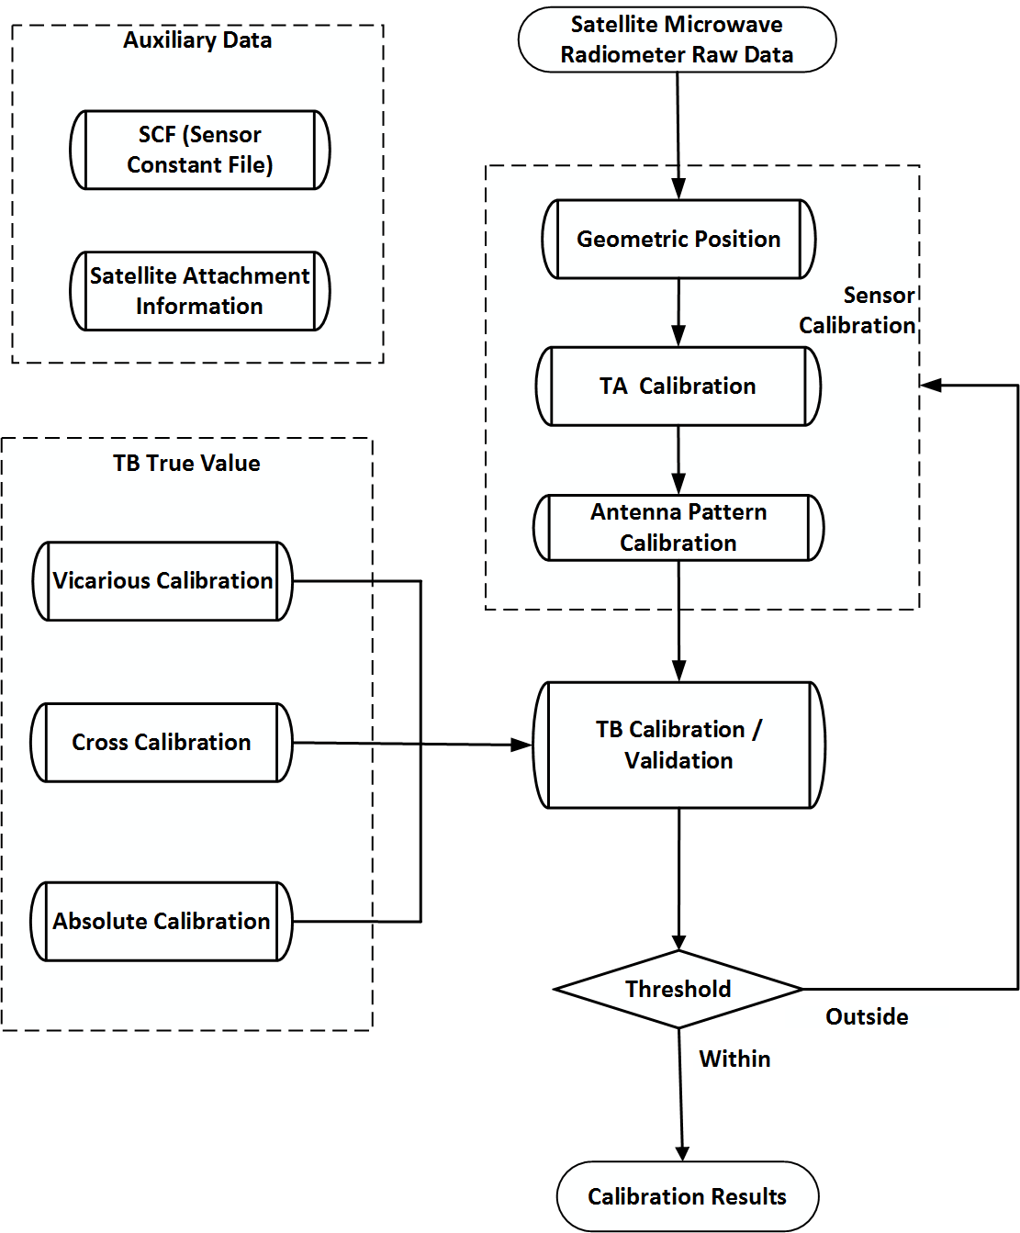

Figure 2 – Flow chart of the microwave radiometer calibration

Calibration of a radiometer begins with “sensor calibration” using “Satellite Microwave Radiometer Raw Data”, which usually include data and parameters for producing a two-point calibration equation. The process of “sensor calibration “generally includes three stages named as “Geometric Position”, “TA calibration” of the receiver, and “Antenna Pattern Calibration” of the antenna. Sensor calibration is a routine in the space-borne microwave radiometer operational system, which is used for producing the data products of L1. It is also necessary in “TB Calibration/Validation” after the differences outside the given “Threshold”, to find the roots of mismatch.

In Figure 2, “TB True Value” serves as input for module “TB Calibration/Validation” (defined in the class “CA_TBCalibrationValidation” in Clause 7.4.1) to calibrate “TB to be calibrated”, and the results will be assessed. If the assessments are within the “Threshold”, the calibrated TB will be outputted as “recalibrated TB”, otherwise, three main processing in the “Sensor Calibration” will be followed for correcting the errors by “Geometric Position” (defined in the class “CA_GeometricPosition” in Clause 7.3.1), “TA Calibration” module (defined in the class “CA_TACalibration” in Clause 7.3.2), and “Antenna Pattern Calibration” (defined in the class “CA_AntennaPatternCalibration” in Clause 7.3.3). The re-calibrated TB as output from “Sensor calibration” will be as new inputs for “TB Calibration/Validation” module, until the final “recalibrated TB” is generated. The “Calibration results”, including the statistics of calibration errors, such as bias of each band, standard deviation, and uncertainty, etc., should also be provided.

## Top-level model

Figure 3 depicts the top-level class diagram of this Technical Specification.

1. /req/specification/Top-levelClass:   
   The classes shown in Figure 3, their attributes and their associations shall be used as described in the data dictionary of B.2, B.9.1, B.9.7, and B.9.10.

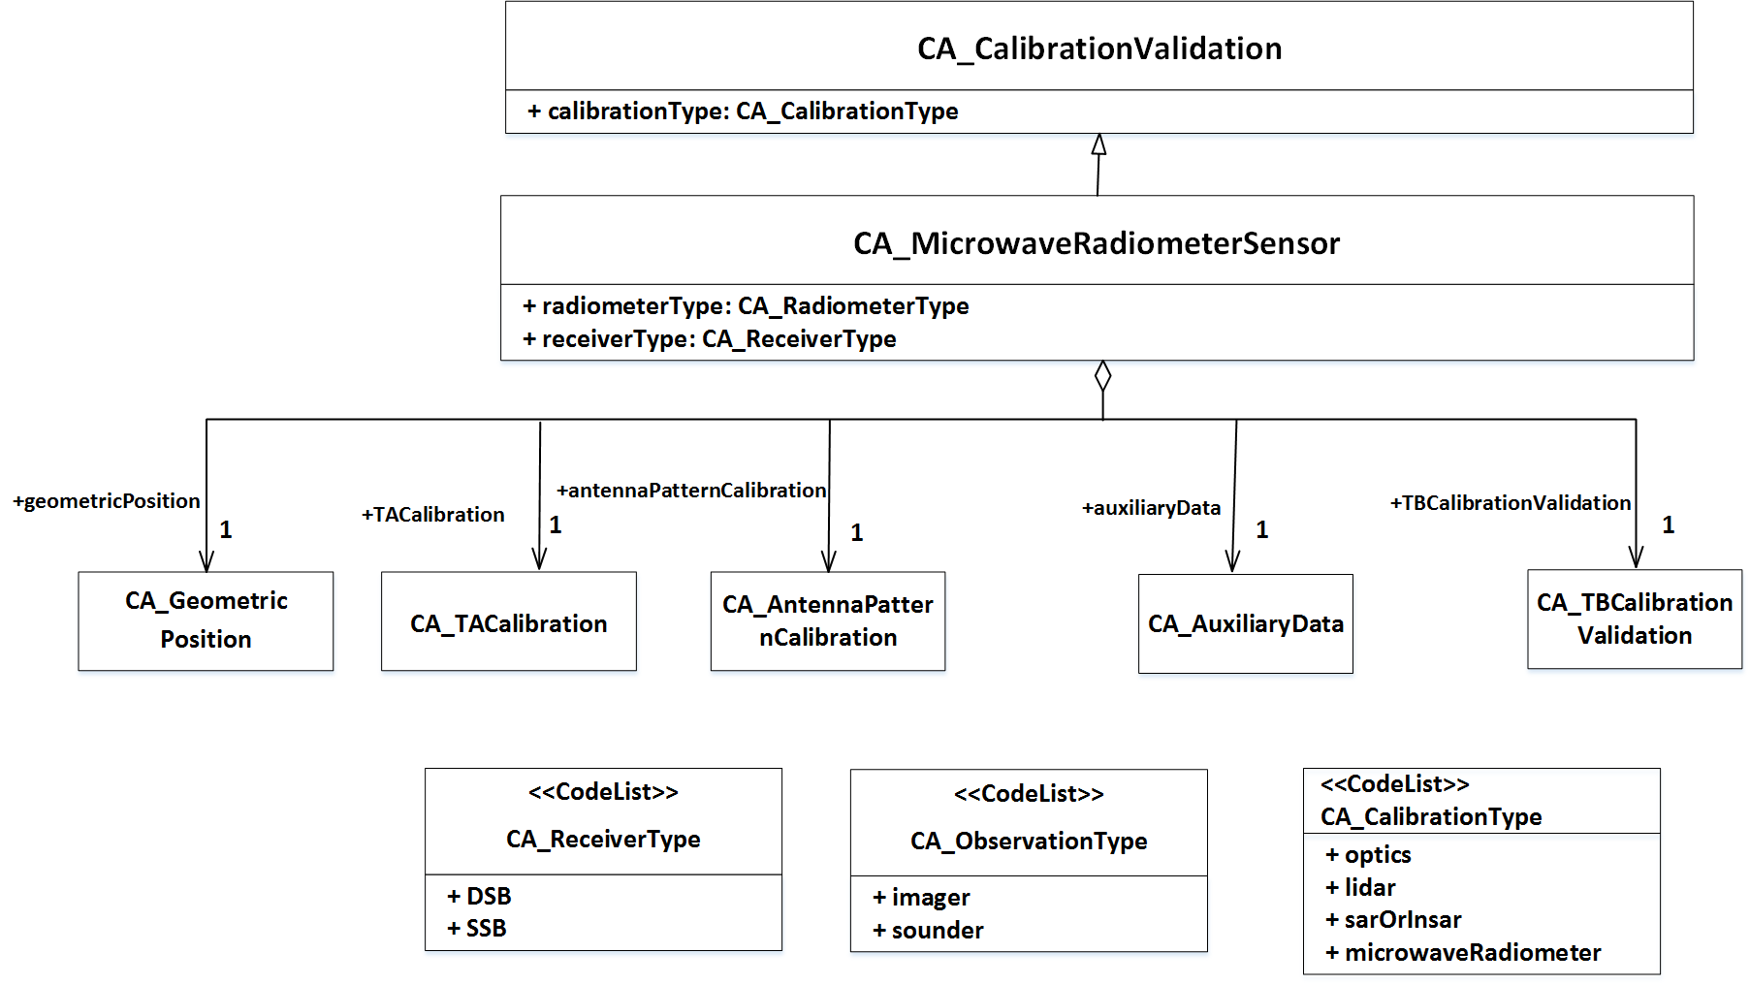

Figure 3 – Class diagram of ISO/TS 19159-4

The class CA_MicrowaveRadiometerSensor is a top-level class for all information of calibration and validation of microwave radiometer sensors. It aggregates five classes named: CA_GeometricPosition, CA_TACalibration, CA_AntennaPatternCalibration, CA_AuxiliaryData and CA_TBCalibrationValidation. The first three classes describe the procedure of the sensor calibration. Details of the geometric position are shown in Figure 4, of the antenna temperature calibration are shown in Figure 5, and of the antenna pattern calibration are shown in Figure 6. CA_AuxiliaryData is needed in the calibration and validation activities, and the details are shown in Figure 7. Details of the brightness temperature (TB) calibration / validation are shown in Figure 8. The details of the classes are shown in Annex B (Data Dictionary).

The attribute receiverType defines the type of the microwave receiver according to the code list set in the class CA_ReceiverType. In the calibration view, radiometer receivers can be categorized into two types: Double Side Band (DSB) ones and Single Side Band (SSB) ones.

The attribute observationType defines the observation type of the microwave radiometer according to the code list set in the class CA_ObservationType. There are two types of the observation: the sounders are usually used for sounding the atmosphere profiles and the imagers are usually used for sensing the Earth surface.

## Sensor calibration

The primary objective of the space-borne satellite radiometer sensor onboard calibration is to find the relationship between the radiometer’s output (usually Voltage) and the input brightness temperature (TB), by means of well-known internal or external targets at different temperatures. The process should count antenna pattern into it for correcting sidelobe, cross-polarization, incidence angle of the boresight and spillover for the reflector-feed system of the antenna.

Usually, sensor calibration is first conducted by the ground system of the satellite mission for producing level-1 product of TB, which is used as input of calibration/validation in Figure 2. According to the positions of the calibrators location, onboard calibration involves antenna pattern correction or calibration when the antenna is not within the path between the two calibrators, such as calibration at the feeds of the receivers using the warm load and the cold space for sensors like AMSR-E, SSM/I, etc. Even if the antenna is within the same path with the calibrators, antenna pattern sidelobe and cross-polarization should be corrected for deriving more accurate TB of the scene.

The purpose of the technical specification will address calibration/validation of the original TB by finding the error by comparing them with those true values and removing them at large from the original TB through correcting the bias or uncertainties in geometry computation, TA calibration and antenna pattern calibration.

### Geometric position

Geometric positioning is an important part in the process of space-borne microwave radiometers calibration. Figure 4 depicts the class diagram of geometric position.

1. /req/specification/GeometricPosition:   
   The classes shown in Figure 4, their attributes and their associations shall be used as described in the data dictionary of B.3.

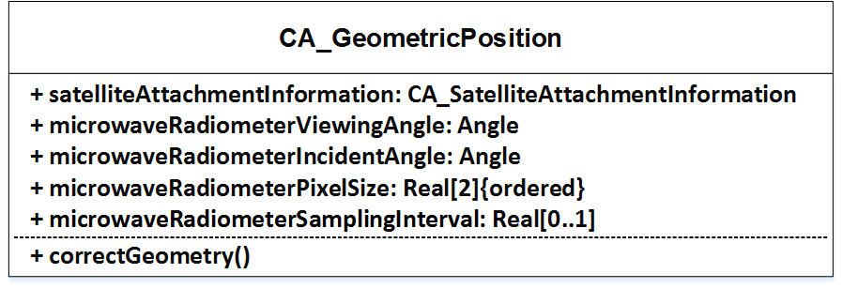

Figure 4 – CA_GeometricPosition class diagram

The class CA_GeometricPosition contains all information about the geometric positioning.

The attribute satelliteAttachmentInformation defines the satellite attachment information. The Definition of the class CA_SatelliteAttachmentInformation can be found in Figure 7.

The attribute microwaveRadiometerViewingAngle defines the microwave radiometer viewing angle (expressed in the nadir angle and azimuth angle of the radiometer boresight).

The attribute microwaveRadiometerIncidentAngle defines the microwave radiometer incident angle (expressed in the nadir angle and azimuth angle of the incident microwave) at the Earth surface.

The attribute microwaveRadiometerPixelSize defines the microwave radiometer pixel size (including two elements: the first is the elevation resolution expressed in kilometres, and the second is the azimuth resolution expressed in kilometres).

The attribute microwaveRadiometerSamplingInterval defines the microwave radiometer sampling interval (expressed in miliseconds).

The operation correctGeometry defines the function to realize the geometric position, the output are latitude, longitude, elevation angle and azimuth angle of the pixel.

### TA Calibration

Microwave Radiometer TA calibration is needed in the process of space-borne microwave radiometers correction.

Figure 5 depicts the class diagram of CA_TACalibration.

1. /req/specification/TACalibration:   
   The classes shown in Figure 5, their attributes and their associations shall be used as described in the data dictionary of B.4, B.9.3 and B.9.5.

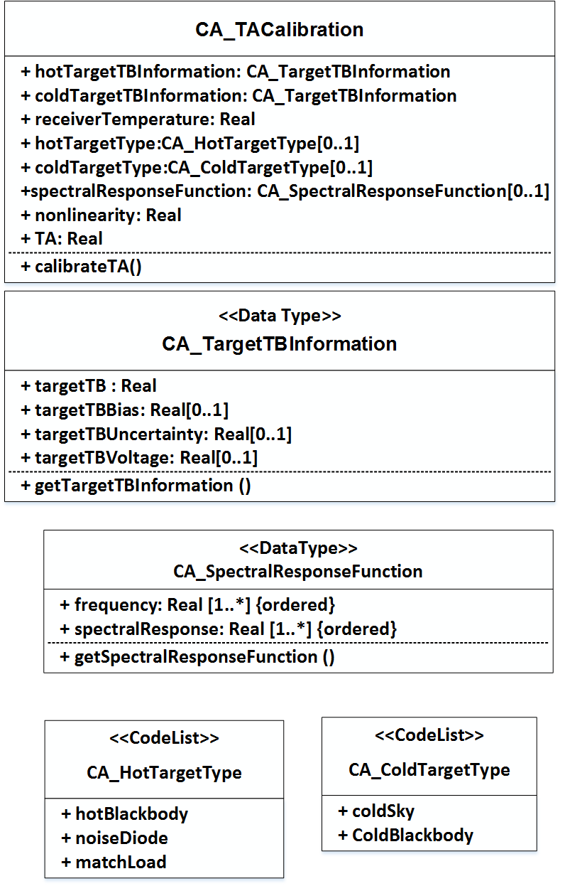

Figure 5 – CA_TACalibration class diagram

The class CA_TACalibration contains all information about the microwave radiometer TA calibration.

The attribute hotTargetTBInformation defines the hot target TB information.

The attribute coldTargetTBInformation defines the cold target TB information.

The attribute receiverTemperature defines the receiver temperature (usually detector’s temperature of the radiometer, or instrument temperature）of the microwave radiometer system.

The attribute hotTargetType defines the type of the hot target according to the code list set in the class CA_hotTargetType. The most common hot-end reference is the hot blackbody.

The attribute coldTargetType defines the type of the cold target according to the code list set in the class CA_ColdTargetType. The most common cold-end reference is the cold sky (CMB).

The attribute spectralResponseFunction defines the spectral response function.

The class CA_SpectralResponseFunction is a data type that defines the spectral response function with respect to the frequency expressed in Hz.

The attribute nonlinearity defines the nonlinear term (often expressed in TB) at different instrument temperatures.

The (output) attribute TA defines the antenna temperature.

The operation calibrateTA defines the function to calibrate the antenna temperature.

### Antenna pattern calibration

Antenna pattern calibration (APC) is needed in the process of space-borne microwave radiometers calibration. Figure 6 depicts the class diagram of antenna pattern calibration.

1. /req/specification/AntennaPatternCalibration:   
   The classes shown in Figure 6, their attributes and their associations shall be used as described in the data dictionary of B.5.

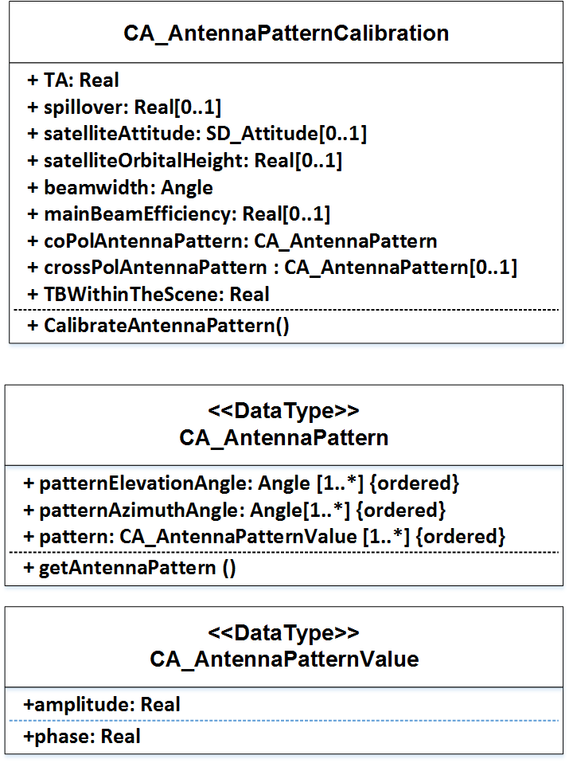

**Figure 6 – CA_AntennaPatternCalibration class diagram**

The class CA_AntennaPatternCalibration contains all information about the APC.

The attribute TA defines the antenna temperature inputted from CA_TACalibration.

The attribute spillover defines the spillover factors of the band.

The attribute satelliteAttitude defines the satellite attitude (expressed in the combination of the omega, phi and kappa components).

The attribute satelliteOrbitalHeight defined the orbital height (expressed in kilometres).

The attribute beamwidth defines the antenna beamwidth (expressed in degrees).

The attribute mainBeamEfficiency defines the antenna main beam efficiency.

The attribute coPolAntennaPattern defines the co-polarization antenna pattern at least in E- and H-cuts.

The attribute crossPolAntennaPattern antenna pattern defines the cross-polarization antenna pattern at least in E- and H-cuts.

The class CA_AnttenaPattern is a data type that defines an antenna pattern in two dimensions (with respect to the elevation angle expressed in degrees and the azimuth angle expressed in degrees).

The (output) attribute TBWithinTheScene defines the TB within the observed scene.

The operation calibrateAntennaPattern defines the function to calibrate the antenna pattern and the coefficients for correcting TA to TB.

## Auxiliary data

The class CA_AuxiliaryData is needed in the process of space-borne microwave radiometers calibration. Figure 7 depicts the class diagram of auxiliary data.

1. /req/specification/AuxiliaryData:   
   The classes shown in Figure 7, their attributes and their associations shall be used as described in the data dictionary of B.6 and B.9.9.

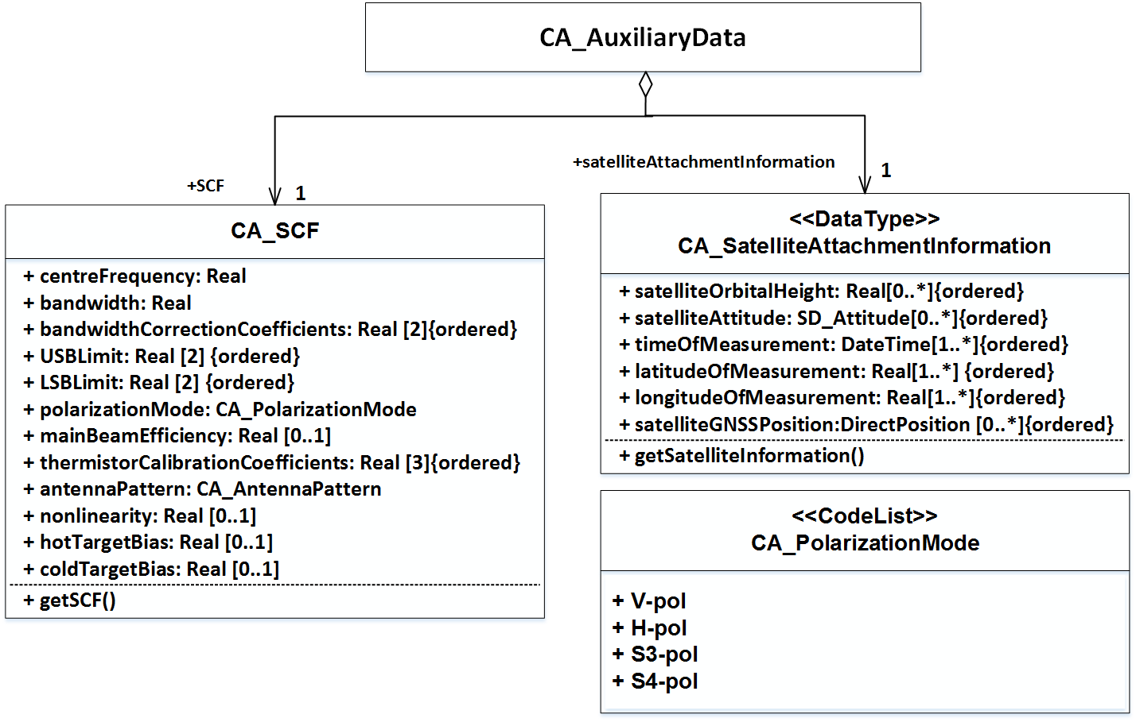

Figure 7 – CA_AuxiliaryData class diagram

The class CA_AuxiliaryData includes two subclass: CA_SCF and CA_SatelliteAttachmentInformation. The former contains the sensor constants needed in the calibration procedure, and the latter provides the information of the platform (satellite) for geometric position.

The class CA_SCF is a data type that defines the Sensor Constants File (SCF) derived from the prelaunch calibration, which includes centreFrequency (expressed in Hz), bandwidth (expressed in Hz), bandwidthCorrectionCoefficients, USBLimit (Upper Side Band limit expressed in Hz), LSBLimit (Lower Side Band limit expressed in Hz,) polarizationMode (identifying the polarization mode corresponding to the TB measurement to be calibrated, including four possibilities: Vertical (V-pol), Horizontal (H-pol), third (S3-pol) and fourth (S4-pol) Stokes parameters), mainBeamEfficiency, thermistorCalibrationCoefficients, antennaPattern, nonlinearity, hotTargetBias and coldTargetBias.

The class CA_ SatelliteAttachmentInformation is a data type that defines the satellite attachment information, which includes satellite orbital height (expressed in kilometres), satellite attitude (expressed in the combination of the omega, phi and kappa components), time of measurement (with the data type “DateTime”), latitude of measurement (expressed in degrees), longitude of measurement (expressed in degrees), satellite GNSS position ([X, Y, Z] coordinates, expressed in meters), etc.

## TB Calibration / Validation

### TB Calibration / Validation class diagram

TB calibration / validation is needed before it is used for deriving geophysical parameters or any other applications. The fundamental function of the TB calibration / validation is to calibrate and validate the TB products (not of the higher-level geophysical products for further users) to compute the bias and standard deviation of the TB relative to an equivalent TB true value.

Figure 8 depicts the class diagram of TB calibration / validation.

1. /req/specification/TBCalibrationValidation:   
   The classes shown in Figure 8, their attributes and their associations shall be used as described in the data dictionary of B.7 and B.9.8.

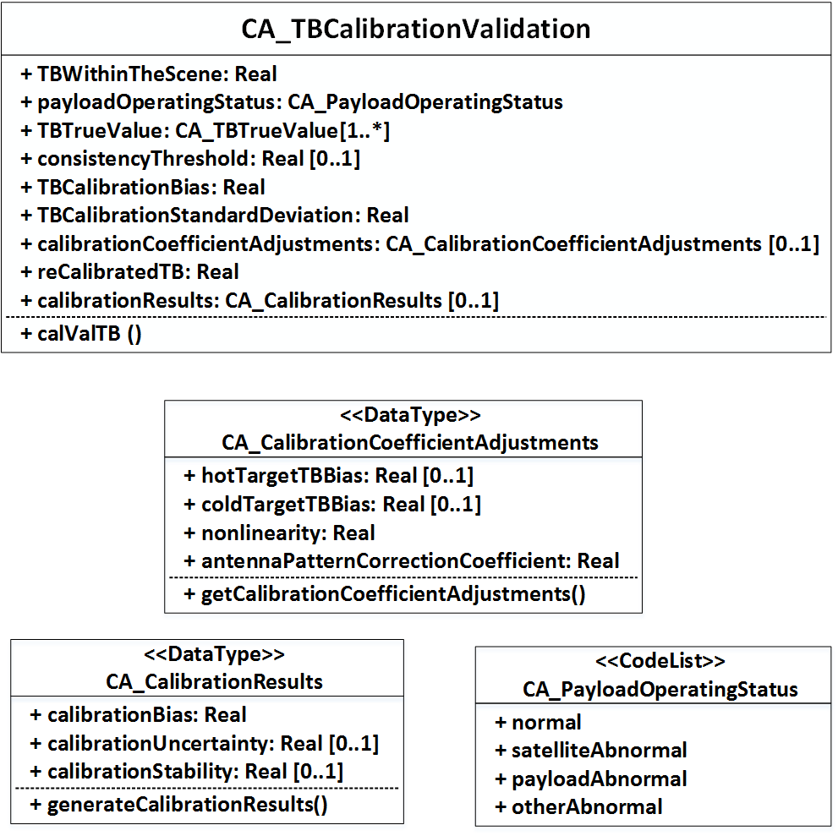

Figure 8 – CA_TBCalibrationValidation class diagram

The class CA_TBCalibrationValidation contains all information about the TB calibration / validation.

The attribute TBWithinTheScene defines the TB of the scene.

The attribute payloadOperatingStatus defines the microwave radiometer payload operating status according to the code list set in the class CA_PayloadOperatingStatus. The status can be normal or abnormal (due to satellite, payload or other factors).

The attribute CA_TBTrueValue defines the equivalent TB true value, which is shown in detail in Figure 9.

The attribute consistencyThreshold defines the consistency threshold.

The (output) attribute TBCalibrationBias defines the TB calibration bias.

The (output) attribute TBCalibrationStandardDeviation defines the TB calibration standard deviation (defined in Clause 3.19).

The (output) attribute calibrationCoefficientAdjustments defines the calibration / validation report, which includes the hot target TB bias, cold target TB bias, nonlinearity, and antenna pattern correction, etc.

The (output) attribute reCalibratedTB defines the re-calibrated TB.

The (output) attribute calibrationResults defines statistics of the calibration results, which includes the calibration bias, calibration uncertainty, calibration stability, etc.

The operation calValTB defines the function to realize the TB calibration / validation.

### TB Calibration / Validation methods

According to the source of TB true value, there are three categories of TB calibration / validation methods, named　vicarious calibration, cross calibration and absolute calibration which can be used to produce “True Value” for validating TB. This technical specification does not include pre-launch calibration in thermal vacuum chamber aiming at deriving nonlinearity coefficients of each band of microwave radiometer, and does not include the process on how to generate the coefficients for on-board calibration.

#### Vicarious calibration

Vicarious calibration, the validation using well-characterized, stable Earth targets, is a fall-back option when a satellite instrument cannot be directly traceable to an agreed reference standard, for example due to the absence of reliable on-board calibration device. Data records from past instruments can be “re-calibrated” retrospectively, if additional information on the state of these instruments becomes available, for example through comparison with reprocessed, well-known historical time series.

The vicarious calibration technique consists of three principle steps. First, calibration algorithms are coded up for each sensor. These algorithms convert raw (Level 0) radiometer digital counts into Level 1 radiometric antenna temperatures –by correcting for on board calibration and other instrumental effects – and then into Level 2 main beam averaged brightness temperatures – by correcting for antenna pattern and spacecraft attitude effects. The vicarious calibration data allows for the identification of errors in sensor calibration. The third step involves characterization of the calibration errors, typically by appropriate sorting and binning of the results of Step 2, followed by an iterative refinement of the Level 1 and Level 2 algorithms to remove the errors. Adequate characterization of the errors is critical to determine which part(s) of the algorithms should be adjusted.

**(1) Cold-end** **vicarious calibration**

The coldest possible brightness temperatures observed by a downward-looking microwave radiometer from space are often produced by calm oceans under cloud free skies and very low humidity. This set of conditions tends to occur with sufficient regularity that a space-borne radiometer will accumulate a useful number of observations within a period of a few days to weeks.

**(2) Hot-end vicarious calibration**

An ideal hot-end target would be a large isothermal blackbody extending over the main beam of the Earth pointing antenna, such as the rain forest.

#### Cross-calibration by simultaneous observations

Cross-calibration of satellite instruments involves relating the measurements of one instrument to those of a high-quality, well-calibrated instrument serving as a reference.

Cross-calibration of instruments operated during the same period requires careful collocation wherein instrument outputs are compared when the instruments are viewing the same Earth scenes, at the same times, from the same viewing angles.

An alternative approach for instrument Cross-calibration, which is less demanding in computation and applicable posteriori to long data series, is to simply compare the statistical distribution of overlapping time series of two satellite instrument data records without imposing individual matches of individual scenes.

#### Absolute calibration

Based on radiative transfer model, a radiometer observation simulation can be constructed, which include the effects of ocean or land surface and atmosphere parameters. A background TB field can be established from the Absolute calibration (also called OMB method) which is used for deriving the difference between simulated and measured TB (from radiometer to be calibrated) to determine the bias and standard deviation of the radiometer TB measurements.

Generally, absolute calibration usually use the ocean surface at clear sky for TB simulations, but the land surface of desert, [tropical rain forest](https://fanyi.baidu.com/#en/zh/tropical%20rain%20forest) and [Antarctic Ice Sheet](https://fanyi.baidu.com/#en/zh/Antarctic%20Ice%20Sheet) are also used for warm TB calibrations.

### TB true value class diagram

Figure 9 depicts the class diagram of TB true value which plays an essential role in the TB calibration / validation and provide data for validating TB.

1. /req/specification/TBTrueValue:   
   The classes shown in Figure 9, their attributes and their associations shall be used as described in the data dictionary of B.8, B.9.2, B.9.4, and B.9.6.

The class CA_TBTrueValue contains all information about the TB true value. CA_TBTrueValue is the parent class of the following three subclasses: CA_VicariousCalibrationTrueValue, CA_CrossCalibrationTrueValue and CA_AbsoluteCalibrationTrueValue. Each subclass corresponds to a certain calibration / validation method described in section 7.4.2. The attributes TBTrueValue and uncertainty in any subclass can be assigned to the class CA_TBTrueValue as required.

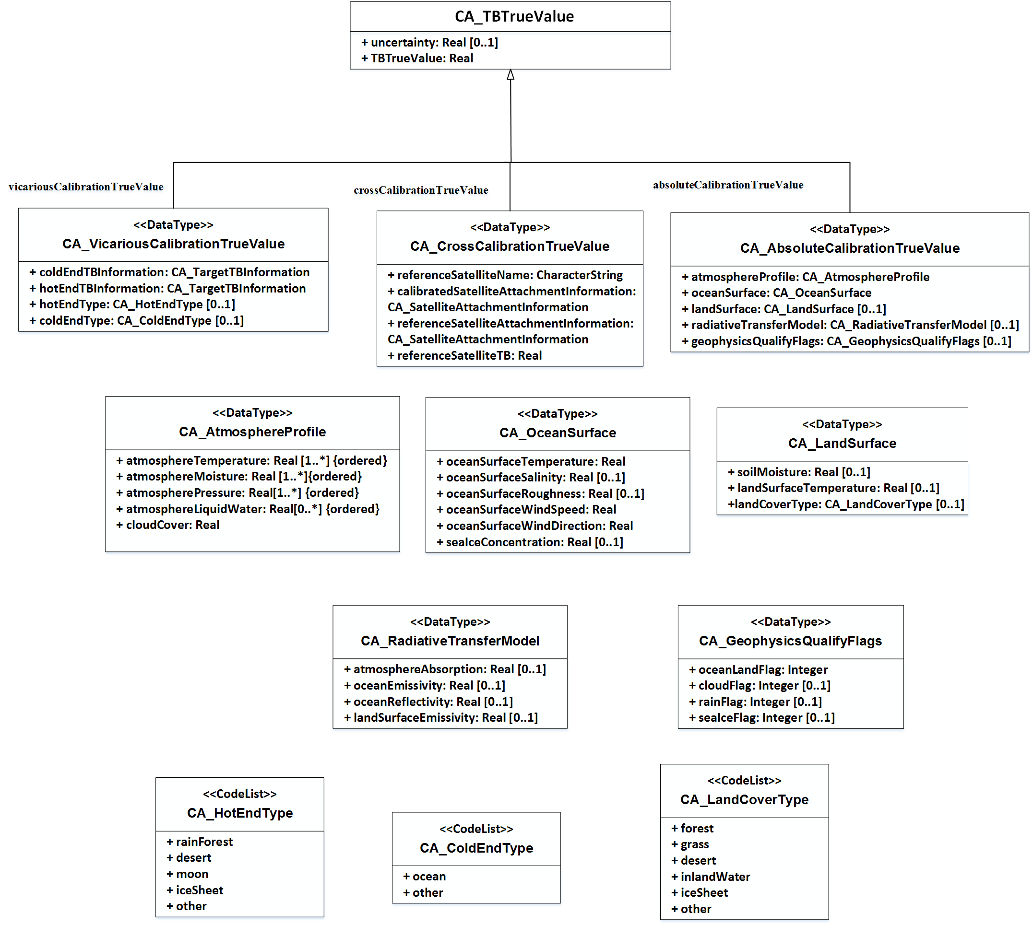

Figure 9 – CA_TBTrueValue class diagram

#### Vicarious calibration true value class diagram

The class CA_VicariousCalibrationTrueValue contains all information about the vicarious calibration TB true values.

The attribute hotEndTBInformation defines the TB information (including at least the TB, the TB bias and the TB uncertainty) of the hot-end.

The attribute coldEndTBInformation defines the TB information (including at least the TB, the TB bias and the TB uncertainty) of the cold-end.

The class CA_TargetTBInformation is a data type that is defined in Figure 5.

The attribute hotEndType defines the type of the hot-end according to the code list set in the class CA_HotEndType. The hot-end reference can be rain forest, desert, moon, ice sheet and others.

The attribute coldEndType defines the type of the cold-end according to the code list set in the class CA_ColdEndType. The most common cold-end reference is the ocean surface.

#### Cross calibration true value class diagram

The class CA_CrossCalibrationTrueValue contains all information about the cross calibration TB true values. There are two types of satellite in this class: the ‘reference’ satellite provides the high-quality TB which can be regarded as a true value, and the ‘calibrated’ satellite produce the TB measurement which need to be calibrated.

The attribute referenceSatelliteName defines the name of the reference satellite.

The attribute calibratedSatelliteAttachmentInformation defines the calibrated satellite attachment information.

The attribute referenceSatelliteAttachmentInformation defines the reference satellite attachment information.

The attribute referenceSatelliteTBdefines thename TB of the reference satellite.

The attribute referenceSatelliteTBMatchCorretiondefines the TB match (with the calibrated satellite) correction term (deviations expressed in Kelvins or equation coefficients of the fitting) to that of the reference satellite.

#### Absolute calibration true value class diagram

The class CA_AbsoluteCalibrationTrueValue contains all information about the TB true values from the absolute calibration method. The absolute calibration true value is determined from simulation based on the radiative transfer model. Auxiliary information of the atmosphere, the ocean surface and the land surface are required in the simulation.

The attribute atmosphereProfile defines the clear sky atmosphere profile, which includes the atmosphere temperature, the atmosphere moisture，the atmosphere pressure etc.

The attribute oceanSurface defines the ocean surface information, which includes the ocean surface temperature, the ocean surface salinity, the ocean wind speed, the ocean wind direction, etc., which are used for computing the ocean surface emissivity and the reflectivity, as well as other parameters related to the scattering of the ocean surface.

The attribute landSurface defines the land surface information, which includes the soil moisture, the land surface temperature, the land cover type, etc., which are used for computing the land surface emissivity and reflectivity, as well as other parameters related to the scattering of the land surface.

The attribute landCoverType in the data type of CA_LandSurface defines the type of the land cover according to the code list set in the class CA_LandCoverType. The land cover type can be forest, grass, desert, inland water, ice sheet and others.

The attribute radiativeTransferModel defines the radiative transfer model parameters, which includes the atmosphere absorption, the surface emissivity and reflectivity models, etc.

The attribute geophysicsQualifyFlags defines a set of geophysics flags such as oceanLandFlag, cloudFlag, rainFlag and seaIceFlag. For all these flags, the data should be rejected as low-qualify data in the calibration process if the flag value equals 1.

## Satellite microwave radiometer Requirement

1. /req/specification/CalibrationDescription:   
   For the calibration description of the imagery from Satellite microwave radiometer sensor, all the mandatory classes and mandatory attributes described in Clause 7 shall be provided.
   * + - 1. (normative)  
              
            Abstract test suite

This Annex specifies an Abstract Test Suite which shall be passed by any implementation claiming conformance with this Technical Specification.

Requirements identifiers below are relative to <http:// standards .isotc211 .org/ iso19159/ -4>

Conformance Test Class: Microwave Radiometer Sensors Calibration/Validation

The URI identifier of this conformance class is: <https://standards.isotc211.org/19159/-4/conf/MicrowaveRadiometerSensors>CalibrationValidation

The URI identifier of this requirements class is: <https://standards.isotc211.org/19159/-4/req/MicrowaveRadiometerSensors>CalibrationValidation

Tests identifiers below are relative to http:// standards .isotc211 .org/ iso19159/ -4

* + 1. Metadata validates

a) Test id: /conf/MicrowaveRadiometerSensorsCalibrationValidation/Top-levelClass

b) Test purpose: Verify that the metadata provided with the image data instantiates CA_MicrowaveRadiometerSensor with its attributes and associated classes.

c) Test method: Inspect the content of the metadata intended to support Satellite microwave radiometer sensors calibration. Test passes if constraint evaluates to be ‘true’. An xml schemaDefinition file has been developed for the test.

d) Reference: /req/MicrowaveRadiometerSensorsCalibrationValidation/Top-levelClass

* + 1. Geometric positioning description validates

a) Test id: /conf/MicrowaveRadiometerSensorsCalibrationValidation/GeometricPosition

b) Test purpose: Verify that the geometric pposition description provided with the image data instantiates CA_MicrowaveRadiometerSensor with its attributes and associated classes.

c) Test method: Inspect the content of the metadata intended to support Satellite microwave radiometer sensors calibration. Test passes if constraint evaluates to be ‘true’. An xml schemaDefinition file has been developed for the test.

d) Reference: /req/MicrowaveRadiometerSensorsCalibrationValidation/GeometricPosition

* + 1. TA Calibration description validates

a) Test id: /conf/MicrowaveRadiometerSensorsCalibrationValidation/TACalibration

b) Test purpose: Verify that the TA Calibration description provided with the image data instantiates CA_MicrowaveRadiometerSensor with its attributes and associated classes.

c) Test method: Inspect the content of the metadata intended to support Satellite microwave radiometer sensors calibration. Test passes if constraint evaluates to be ‘true’. An xml schemaDefinition file has been developed for the test.

d) Reference: /req/MicrowaveRadiometerSensorsCalibrationValidation/TACalibration

* + 1. Antenna pattern calibration description validates

a) Test id: /conf/MicrowaveRadiometerSensorsCalibrationValidation/AntennaPatternCalibration

b) Test purpose: Verify that the antenna pattern calibration description provided with the image data instantiates CA_MicrowaveRadiometerSensor with its attributes and associated classes.

c) Test method: Inspect the content of the metadata intended to support Satellite microwave radiometer sensors calibration. Test passes if constraint evaluates to be ‘true’. An xml schemaDefinition file has been developed for the test.

d) Reference: /req/MicrowaveRadiometerSensorsCalibrationValidation/AntennaPatternCalibration

* + 1. Auxiliary Data description validates

a) Test id: /conf/MicrowaveRadiometerSensorsCalibrationValidation/AuxiliaryData

b) Test purpose: Verify that the aauxiliary data provided with the image data instantiates CA_MicrowaveRadiometerSensor with its attributes and associated classes.

c) Test method: Inspect the content of the metadata intended to support Satellite microwave radiometer sensors calibration. Test passes if constraint evaluates to be ‘true’. An xml schemaDefinition file has been developed for the test.

d) Reference: /req/MicrowaveRadiometerSensorsCalibrationValidation/AuxiliaryData

* + 1. TB Calibration / Validation description validates

a) Test id: /conf/MicrowaveRadiometerSensorsCalibrationValidation/TBCalibrationValidation

b) Test purpose: Verify that the TB Calibration/Validation description provided with the image data instantiates CA_MicrowaveRadiometerSensor with its attributes and associated classes.

c) Test method: Inspect the content of the metadata intended to support Satellite microwave radiometer sensors calibration. Test passes if constraint evaluates to be ‘true’. An xml schemaDefinition file has been developed for the test.

d) Reference: /req/MicrowaveRadiometerSensorsCalibrationValidation/TBCalibrationValidation

* + 1. TB True Value description validates

a) Test id: /conf/MicrowaveRadiometerSensorsCalibrationValidation/TBTrueValue

b) Test purpose: Verify that the TB True Value description provided with the image data instantiates CA_MicrowaveRadiometerSensor with its attributes and associated classes.

c) Test method: Inspect the content of the metadata intended to support Satellite microwave radiometer sensors calibration. Test passes if constraint evaluates to be ‘true’. An xml schemaDefinition file has been developed for the test.

d) Reference: /req/MicrowaveRadiometerSensorsCalibrationValidation/TBTrueValue

* + 1. Calibration Description description validates

a) Test id: /conf/MicrowaveRadiometerSensorsCalibrationValidation/CalibrationDescription

b) Test purpose: Verify that the calibration description provided with the image data instantiates CA_MicrowaveRadiometerSensor with its attributes and associated classes.

c) Test method: Inspect the content of the metadata intended to support Satellite microwave radiometer sensors calibration. Test passes if constraint evaluates to be ‘true’. An xml schemaDefinition file has been developed for the test.

d) Reference: /req/MicrowaveRadiometerSensorsCalibrationValidation/CalibrationDescription

* + - * 1. (normative)  
             
           Data dictionary

**B.1 General**

This annex provides a detailed description of each of the classes and each class attribute in the models presented in this document in the form of a tabular data dictionary.

**B.2 Overview of Microwave Radiometer sensors (Figure 3)**

|  |  |  |  |  |  |  |
| --- | --- | --- | --- | --- | --- | --- |
|  | **Name/Rolename** | **Definition or description** | **Obligation/ Condition** | **Max occurrence** | **Data type/Class** | **Domain** |
| 1. | CA_CalibrationValidation | Root entity that defines information about calibration | Use obligation/ condition from referencing object | Use maximum occurrence from referencing object | AggregatedClass (MD_CoverageDescription) | Line 2 |
| 2. | calibrationType | Characterization of the calibration coded with the data type CA_CalibrationType | M | 1 | CA_CalibrationType |  |
| 3. | CA_MicrowaveRadiometerSensor | Top-level class for all calibration information of microwave radiometer sensors | Use obligation/condition from referencing object | Use maximum occurrence from referencing object | SpecifiedClass  (CA_CalibrationValidation) | Line 4 to 10 |
| 4. | observationType | Observation type of the microwave radiometer sensor | M | 1 | CA_observationType | Imager or sounder |
| 5. | receiverType | Type of the microwave radiometer receiver | M | 1 | CA_ReceiverType | SSB or DSB |
| 6. | *Rolename:*  TACalibration | Antenna temperature calibration, the antenna temperature is acquired after the calibration on the receiver. | M | 1 | CA_TACalibration, | Calibration to the receiver of a microwave radiometer |
| 7. | *Rolename:*  antennaPatternCalibration | Antenna pattern calibration in which antenna pattern sidelobe and cross-polarization should be corrected for deriving more accurate TB of the scene | M | 1 | CA_AntennaPatternCalibration | Antenna pattern correction |

|  |  |  |  |  |  |  |
| --- | --- | --- | --- | --- | --- | --- |
|  | **Name/Rolename** | **Definition or description** | **Obligation/ Condition** | **Max occurrence** | **Data type/Class** | **Domain** |
| 8. | *Rolename:* geometricPosition | Geometric positioning which can accounting for the bias or uncertainties in geometry computation | M | 1 | CA_GeometricPosition | Latitude and longitude of the pixel. |
| 9. | *Rolename:* auxiliaryData | Auxiliary Data including SCF and satellite attachment information | M | 1 | CA_AuxiliaryData |  |
| 10. | *Rolename:*  TBCalibrationValidation | Calibration and validation of the brightness temperature product | M | 1 | CA_TBCalibrationValidation |  |

**B.3 Geometric Position (Figure 4)**

|  |  |  |  |  |  |  |
| --- | --- | --- | --- | --- | --- | --- |
|  | **Name/Rolename** | **Definition or description** | **Obligation/ Condition** | **Max occurrence** | **Data type/ Class** | **Domain** |
| 11. | CA_GeometricPosition | Information related to the geometric correction of the microwave radiometer system | Use obligation/ condition from referencing object | Use maximum occurrence from referencing object | Aggregated  Class  (CA_MicrowaveRadiometerSensor) | Line 12 to 16 |
| 12. | satelliteAttachmentInformation | Satellite attachment information | M | 1 | CA_satelliteAttachmentInformation |  |
| 13. | microwaveRadiometerViewingAngle | Microwave radiometer viewing angle with respect to the platform | M | 1 | Angle | >=0, ISO 19103 |
| 14. | microwaveRadiometerIncidentAngle | Microwave radiometer incident angle with respect to the earth surface | M | 1 | Angle | >=0, ISO 19103 |
| 15. | microwaveRadiometerPixelSize | Microwave radiometer pixel size (expressed in the elevation resolution multiplies the azimuth resolution) | M | 1 | Real[2] | >0, the unit is kilometre multiplies kilometre |
| 16. | microwaveRadiometerSamplingInterval | Microwave radiometer sampling interval between the successive samples in a scan. | O | 1 | Real | >0, the unit is millisecond |

**B.4 TA Calibration (Figure 5)**

|  |  |  |  |  |  |  |
| --- | --- | --- | --- | --- | --- | --- |
|  | **Name/Rolename** | **Definition or description** | **Obligation/Condition** | **Max occurrence** | **Data type/ Class** | **Domain** |
| 17. | CA_TACalibration | Information related to the antenna temperature calibration of the microwave radiometer system | Use obligation/ condition from referencing object | Use maximum occurrence from referencing object | Aggregated  Class  (CA_MicrowaveRadiometerSensor) | Line 18 to 25 |
| 18. | hotTargetTBInformation | Hot target TB information | M | 1 | CA_TargetTBInformation |  |
| 19. | coldTargetTBInformation | Cold target TB information | M | 1 | CA_TargetTBInformation |  |
| 20. | receiverTemperature | operation temperature of the microwave radiometer receiver | M | 1 | Real | 240<= receiverTemperature - > Value <= 350, the unit is Kelvin |
| 21. | hotTargetType | Hot target type | O | 1 | CA_HotTargetType |  |
| 22. | coldTargetType | Cold target type | O | 1 | CA_coldTargetType |  |
| 23. | spectralResponseFunction | Spectral response function | O | 1 | CA_SpectralResponseFunction |  |
| 24. | nonlinearity | Nonlinear term of the antenna temperature for the receiver temperature | M | 1 | Real | Unrestricted， the unit is Kelvin |
| 25. | TA | Antenna temperature(output attribute) | M | 1 | Real | 0<=TA - > Value <= 350, the unit is Kelvin |

|  |  |  |  |  |  |  |
| --- | --- | --- | --- | --- | --- | --- |
|  | **Name/Rolename** | **Definition or description** | **Obligation/Condition** | **Max occurrence** | **Data type/ Class** | **Domain** |
| 26. | CA_SpectralResponseFunction | Data type that defines the spectral response function of the microwave radiometer sensor | Use obligation / condition from referencing object | Use maximum occurrence from referencing object | Class <<Data type>> | Line 27-28 |
| 27 | frequency | Frequency | M | 1 | Real {ordered} | >0, the unit is GHz |
| 28 | spectralResponse | Response weights or radio at the frequencies within the bandwidth of the receiver | M | 1 | Real {ordered} | Usually in normalized weights in dB, -100 <= spectralResponse ->Value<= 0 |
| 29 | CA_TargetTBInformation | Data type that defines the target (either hot or cold) TB information | Use obligation / condition from referencing object | Use maximum occurrence from referencing object | Class <<Data type>> | Line 30–33 |
| 30. | targetTB | TB from the measured target, usually form varied-temperature blackbody | M | 1 | Real | 0<= targetTB - > Value <= 350, the unit is Kelvin |
| 31. | targetTBBias | Bias in TB of the target | O | 1 | Real | the unit is Kelvin |
| 32. | targetTBUncertainty | Uncertainty in TB of the target | O | 1 | Real | >0, the unit is Kelvin |
| 33. | targetTBVoltage | Microwave radiometer output in voltage or count | O | 1 | Real | the unit is Volt or count |

**B.5 Antenna Pattern Calibration (Figure 6)**

|  | **Name/Rolename** | **Definition or description** | **Obligation/ Condition** | **Max occurrence** | **Data type/ Class** | **Domain** |
| --- | --- | --- | --- | --- | --- | --- |
| 34. | CA_AntennaPatternCalibration | Information related to the antenna pattern calibration of the microwave radiometer system | Use obligation / condition from referencing object | Use maximum occurrence from referencing object | Aggregated  Class  (CA_MicrowaveRadiometerSensors) | Line 35 to 43 |
| 35. | TA | Antenna temperature | M | 1 | Real | 0<=TA - > Value <= 350, the unit is Kelvin |
| 36. | spillover | Spillover | O | 1 | Real | 0<=spillover- > Value <= 1 |
| 37. | satelliteAttitude | Satellite attitude expressed in the combination of the omega, phi and kappa components | O | 1 | SD_Attitude | ISO/TS19130 |
| 38. | satelliteOrbitalHeight | Satellite orbital height | O | 1 | Real | >0, the unit is kilometres |
| 39. | beamwidth | Antenna beam width | M | 1 | Angle | >0 |
| 40. | mainBeamEfficiency | Antenna main beam efficiency | O | 1 | Real | 0<meanBeamEfficiency - > Value < 1 |
| 41. | coPolAntennaPattern | Co-polarization antenna pattern | M | 1 | CA_AntennaPattern | Data for antenna pattern at the co-polarization |
| 42. | crossPolAntennaPattern | Cross-polarization antenna pattern | O | 1 | CA_AntennaPattern | Data for antenna pattern at the cross-polarization |
| 43. | TBWithinTheScene | TB within the scene (output attribute) | M | 1 | Real | 0< TBWithinTheScene - > Value <= 350, the unit is Kelvin |

|  | **Name/Rolename** | **Definition or description** | **Obligation/ Condition** | **Max occurrence** | **Data type/ Class** | **Domain** |
| --- | --- | --- | --- | --- | --- | --- |
| 44. | CA_AntennaPattern | Data type that defines the antenna pattern in the elevation and azimuth dimensions | Use obligation/ condition from referencing object | Use maximum occurrence from referencing object | Class <<Data type>> | Line 45–47 |
| 45. | patternElevationAngle | Elevation angle | M | 1 | Angle {ordered} | -90<= patternElevationAngle - > Value <= 90 |
| 46. | patternAzimuthAngle | Azimuth angle | M | 1 | Angle {ordered} | -180<= patternAzimuthAngle - > Value <= 180 |
| 47. | pattern | Complex pattern including the amplitude and phase at different elevation angles and azimuth angles, at least given in E- and H- cuts of the ports of the antenna. | M | 1 | CA_ AntennaPatternValue {ordered} |  |
| 48. | CA_AntennaPatternValue | Data type that defines the antenna pattern value | Use obligation/ condition from referencing object | Use maximum occurrence from referencing object | Class <<Data type>> | Line 49–50 |
| 49 | amplitude | Amplitude of the antenna pattern | M | 1 | Real | <0, the unit is decibel, or dB |
| 50 | phase | Phase of the antenna pattern | M | 1 | Real | 0<= phase - > Value <= 360 |

**B.6 Auxiliary Data (Figure 7)**

|  |  |  |  |  |  |  |
| --- | --- | --- | --- | --- | --- | --- |
|  | **Name/Rolename** | **Definition or description** | **Obligation/ Condition** | **Max occurrence** | **Data type/ Class** | **Domain** |
| 51. | CA_AuxiliaryData | Information related to the auxiliary data that are needed in the MR calibration procedure. | Use obligation/ condition from referencing object | Use maximum occurrence from referencing object | Aggregated  Class  (CA_MicrowaveRadiometerSensor) | Line 52 to 71 |
| 52. | CA_SatelliteAttachmentInformation | Data type that defines the satellite attachment information | Use obligation/ condition from referencing object | Use maximum occurrence from referencing object | Aggregated  Class(CA_AuxiliaryData) | Line 50 to 55 |
| 53. | satelliteOrbitalHeight | Satellite orbital height with respect to the reference ellipsoid. | O | 1 | Real {ordered} | >0, the unit is km |
| 54. | satelliteAttitude | Satellite attitude expressed in the combination of the omega, phi and kappa components | O | 1 | SD_Attitude{ordered} | ISO/TS19130 |
| 55. | timeOfMeasurement | Time of measurement | M | 1 | DateTime{ordered} | ISO19103  Unrestricted |
| 56. | latitudeOfMeasurement | Latitude of measurement | M | 1 | Real {ordered} | -90 <= latitudeOfMeasurement ->Value<= 90, the unit is degree |
| 57. | longitudeOfMeasurement | Longitude of measurement | M | 1 | Real{ordered} | -180 <= longitudeOfMeasurement ->Value<= 180, the unit is degree |
| 58. | satelliteGNSSPosition | Satellite GNSS position ([X, Y, Z] coordinates, expressed in meters), | O | 1 | DirectPosition{ordered} | ISO 19107 |

|  |  |  |  |  |  |  |
| --- | --- | --- | --- | --- | --- | --- |
|  | **Name/Rolename** | **Definition or description** | **Obligation/ Condition** | **Max occurrence** | **Data type/ Class** | **Domain** |
| 59. | CA_SCF | Sensor Constant File used for calibration |  |  | Aggregated  Class(CA_AuxiliaryData) | Line 57 to 68 |
| 60. | centreFrequency | Centre frequency of the microwave radiometer sensor | M | 1 | Real | 0.1<= centreFrequency - > Value <= 3000, the unit is GHz |
| 61. | bandwidth | Bandwidth of the microwave radiometer receiver | M | 1 | Real | >0, the unit is GHz |
| 62. | bandwidthCorrectionCoefficients | Bandwidth correction coefficients including 2 items of the first-order correction | M | 1 | Real [2] | Including 2 items: the 1st item is non-dimensional, the unit of the 2nd is Kelvin. |
| 63. | USBLimit | Frequency range of the Upper Side Band | M | 1 | Real {ordered} | >0, the unit is GHz |
| 64. | LSBLimit | Frequency range of the Lower Side Band | M | 1 | Real {ordered} | >0, the unit is GHz |
| 65. | polarizationMode | Polarization mode of the radiometer TB measurement, usually referring to vertical or horizontal polarization, which corresponding to the first two modified Stokes parameters, most generally referring to one of the four Stokes parameters. | M | 1 | CA_PolarizationMode | vertical-polarization, horizontal polarization, the third Stokes parameter, the fourth Stokes parameter |
| 66. | mainBeamEfficiency | Antenna main beam efficiency | O | 1 | Real | 0<mainBeamEfficiency - > Value <= 1 |
| 67. | thermistorCalibrationCoefficients | Thermistor calibration coefficients | M | 1 | Real [3] | Including 3 items: the unit of the 1st is Kelvin / Volt2, of the 2nd is Kelvin / Volt, of the 3rd is Kelvin. |
| 68. | antennaPattern | Antenna pattern at a given frequency within a range of elevation angles and azimuth angles | M | 1 | CA_AntennaPattern | Data for antenna pattern at co-polariation and cross-polarization |

|  |  |  |  |  |  |  |
| --- | --- | --- | --- | --- | --- | --- |
|  | **Name/Rolename** | **Definition or description** | **Obligation/ Condition** | **Max occurrence** | **Data type/ Class** | **Domain** |
| 69. | nonlinearity | Nonlinear term at different operation temperatures of the radiometer. | O | 1 | Real | Unrestricted, the unit is Kelvin |
| 70. | hotTargetBias | Bias in TB of the Hot target blackbody | O | 1 | Real | Unrestricted, the unit is Kelvin |
| 71. | coldTargetBias | Bias in TB of the Cold target. | O | 1 | Real | Unrestricted, the unit is Kelvin |

**B.7 TB Calibration Validation (Figure 8)**

|  |  |  |  |  |  |  |
| --- | --- | --- | --- | --- | --- | --- |
|  | **Name/Rolename** | **Definition or description** | **Obligation/ Condition** | **Max occurrence** | **Data type/ Class** | **Domain** |
| 72. | CA_TBCalibrationValidation | Calibration / Validation of the TB. | Use obligation/ condition from referencing object | Use maximum occurrence from referencing object | Aggregated Class  (CAMicrowaveRadiometerSensors) | Line 73 to 81 |
| 73. | TBWithinTheScene | TB within the scene of the microwave radiometer | M | 1 | Real | 0< TBWithinTheScene - > Value <= 350 the unit is Kelvin |
| 74. | payloadOperatingStatus | Payload operating status | M | 1 | CA_PayloadOperatingStatus |  |
| 75. | TBTrueValue | The equivalent TB true value | M | 1 | CA_TBTrueValue | 0< TBTrueValue > Value <= 350, the unit is Kelvin |
| 76. | consistencyThreshold | Consistency threshold | O | 1 | Real | Unrestricted, the unit is Kelvin |
| 77. | TBCalibrationBias | TB calibration bias (output attribute) | M | 1 | Real | Unrestricted, the unit is Kelvin |
| 78. | TBCalibrationStandardDeviation | TB calibration standard deviation (output attribute) | M | 1 | Real | >=0, the unit is Kelvin |
| 79. | calibrationCoefficientAdjustments | Calibration adjustment coefficients (output attribute) | O | 1 | CA_CalibrationCoefficientAdjustments |  |

|  |  |  |  |  |  |  |
| --- | --- | --- | --- | --- | --- | --- |
|  | **Name/Rolename** | **Definition or description** | **Obligation/ Condition** | **Max occurrence** | **Data type/ Class** | **Domain** |
| 80. | reCalibratedTB | Re-calibrated TB (output attribute) | M | 1 | Real | >0, the unit is Kelvin |
| 81. | calibrationResults | Parameters in the calibration / validation report (output attribute) | O | 1 | CA_CalibrationResults |  |
| 82. | CA_CalibrationCoefficient Adjustments | Data type that defines the calibration adjustment coefficients | Use obligation/ condition from referencing object | Use maximum occurrence from referencing object | Class <<Data type>> | Line 83–86 |
| 83. | hotTargetTBBias | Hot target BT bias | O | 1 | Real | Unrestricted, the unit is Kelvin |
| 84. | coldTargetTBBias | Cold target BT bias | O | 1 | Real | Unrestricted, the unit is Kelvin |
| 85. | nonlinearity | Nonlinearity correction | M | 1 | Real | Unrestricted, the unit is Kelvin |
| 86. | antennaPatternCorrectionCoefficient | Antenna pattern correction coefficient | M | 1 | Real {ordered} | 0<= antennaPatternCorrectionCoefficient ->Value<= 1 |
| 87. | CA_CalibrationResults | Data type that defines the calibration / validation results | Use obligation/ condition from referencing object | Use maximum occurrence from referencing object | Class <<Data type>> | Line 88–90 |
| 88. | calibrationBias | Calibration bias | M | 1 | Real | Unrestricted, the unit is Kelvin |
| 89. | calibrationUncertainty | Calibration uncertainty | O | 1 | Real | Unrestricted, the unit is Kelvin |
| 90. | calibrationStability | Calibration stability | O | 1 | Real | the unit is Kelvin/annual |

**B.8 TB True Value (Figure 9)**

|  | **Name/Rolename** | **Definition or description** | **Obligation/Condition** | **Max occurrence** | **Data type/ Class** | **Domain** |
| --- | --- | --- | --- | --- | --- | --- |
| 91. | CA_TBTrueValue | TB True Value | Use obligation/ condition from referencing object | Use maximum occurrence from referencing object | Generalized Class | Line 92 to 93 |
| 92. | TBTrueValue | TB true value. If TBTrueValueType=vicariousCalibration, TBTrueValueValue= CA_VicariousCalibrationTrueValue.vicariousCalibrationTBValue; if TBTrueValueType=crossCalibration, TBTrueValueValue= CA_CrossCalibrationTrueValue.crossCalibrationTBValue; if TBTrueValueValue= CA_AbsoluteCalibrationTrueValue.absoluteCalibrationTBValue. | M | 1 | CA_TBTrueValue | 0< TBTrueValueValue -> Value <= 350, the unit is Kelvin |
| 93. | uncertainty | Uncertainty of the true value | O | 1 | Real[0..1] |  |
| 94. | CA_AbsoluteCalibrationTrueValue | Absolute calibration true value | Use obligation/ condition from referencing object | Use maximum occurrence from referencing object | Inherited Class (CA_TBTrueValue) | Line 95 to 99 |
| 95. | atmosphereProfile | Atmosphere profiles for computing using radiative transfer model | M | 1 | CA_AtmosphereProfile |  |
| 96. | oceanSurface | Ocean surface parameters for computing using radiative transfer model | M | 1 | CA_OceanSurface |  |
| 97. | landSurface | Land surface parameters for computing using radiative transfer model | O | 1 | CA_LandSurface |  |
| 98. | radiativeTransferModel | Microwave Radiative transfer model for simulating the TB co-located to the satellite sensing. | O | 1 | CA_RadiativeTransferModel |  |
| 99. | geophysicsQualifyFlags | Geo-location flags for qualifying the calibration | O | 1 | CA_GeophysicsQualifyFlags |  |
| 100. | CA_AtmosphereProfile | Data type that defines the atmosphere profile | Use obligation/ condition from referencing object | Use maximum occurrence from referencing object | Class <<Data type>> | Line 101–105 |
| 101. | atmosphereTemperature | Atmosphere temperature profile | M | 1 | Real {ordered} | >0, the unit is Kelvin |
| 102. | atmosphereHumidity | Atmosphere humidity profile | M | 1 | Real {ordered} | 0<=atmosphereMoisture ->Value<= 1, the unit is kg/kg |
| 103. | atmospherePressure | Atmosphere pressure profile | M | 1 | Real {ordered} | >0, the unit is Pascal |
| 104. | atmosphereLiquidWater | Atmosphere liquid water profile | O | 1 | Real {ordered} | >=0, the unit is kg/kg |
| 105. | cloudCover | Cloud cover percentage | O | 1 | Real | 0<=cloudCover ->Value<= 100, the unit is percentage |
| 106. | CA_CrossCalibrationTrueValue | Cross calibration true value | Use obligation/ condition from referencing object | Use maximum occurrence from referencing object | Inherited Class (CA_TBTrueValue) | Line 107 to 110 |
| 107. | referenceSatelliteName | Reference satellite name | M | 1 | CharacterString |  |
| 108. | calibratedSatelliteAttachmentInformation | Calibrated satellite attachment information | M | 1 | CA_SatelliteAttachmentInformation |  |
| 109. | referenceSatelliteAttachmentInformation | Reference satellite attachment information | M | 1 | CA_SatelliteAttachmentInformation |  |
| 110. | referenceSatelliteTB | Reference satellite TB | M | 1 | Real | 0<= referenceSatelliteTB - > Value <= 350, the unit is Kelvin |

|  |  |  |  |  |  |  |
| --- | --- | --- | --- | --- | --- | --- |
|  | **Name/Rolename** | **Definition or description** | **Obligation/ Condition** | **Max occurrence** | **Data type/ Class** | **Domain** |
| 111. | CA_GeophysicsQualifyFlags | Data type that defines the geophysics qualify flags. If any of the flag equals 1, the data should be rejected in the calibration process. | Use obligation/ condition from referencing object | Use maximum occurrence from referencing object | Class <<Data type>> | Line 112–115 |
| 112. | oceanLandFlag | Flag indicating the presence of land within the scene. The Flag can be determined from the land-ocean mask. | M | 1 | Integer | =0 for ocean; =1 for land or coast |
| 113. | cloudFlag | Flag indicating the presence of cloud in the path of the observation. | O | 1 | Integer | =0 for no cloud; =1 for presence of cloud |
| 114. | rainFlag | Flag indicating the presence of rain in the path of the observation. | O | 1 | Integer | =0 for no rain; =1 for presence of rain |
| 115. | seaIceFlag | Flag indicating the presence of sea ice within the scene. | O | 1 | Integer | =0 for no sea ice; =1 for presence of sea ice |
| 116. | CA_LandSurface | Data type that defines the land surface information | Use obligation/ condition from referencing object | Use maximum occurrence from referencing object | Class <<Data type>> | Line 117–119 |
| 117. | soilMoisture | Soil moisture | O | 1 | Real | 0<=soilMoisture->Value<= 100, the unit is percentage |
| 118. | landSurfaceTemperature | Land surface temperature | O | 1 | Real | 0< landSurfaceTemperature ->Value<= 350, the unit is Kelvin |
| 119. | landCoverType | Land cover type | M | 1 | CA_LandCoverType |  |

|  |  |  |  |  |  |  |
| --- | --- | --- | --- | --- | --- | --- |
|  | **Name/Rolename** | **Definition or description** | **Obligation/Condition** | **Max occurrence** | **Data type/ Class** | **Domain** |
| 120. | CA_OceanSurface | Data type that defines the ocean surface information | Use obligation / condition from referencing object | Use maximum occurrence from referencing object | Class <<Data type>> | Line 121–126 |
| 121. | oceanSurfaceTemperature | Ocean surface temperature | M | 1 | Real | >0, the unit is Kelvin |
| 122. | oceanSurfaceSalinity | Ocean surface salinity | O | 1 | Real | the unit is ‰ |
| 123. | oceanSurfaceRoughness | Ocean surface roughness | O | 1 | Real | the unit is degree |
| 124. | oceanSurfaceWindSpeed | Ocean surface wind speed | M | 1 | Real | the unit is m/s |
| 125. | oceanSurfaceWind Direction | Ocean surface wind direction (with respect to the North) | M | 1 | Real | 0<=oceanSurfaceWindDirection ->Value<= 360, the unit is degree |
| 126. | seaIceConcentration | Sea ice concentration | O | 1 | Real | 0<=seaIceConcentration ->Value<= 100, the unit is percentage |
| 127. | CA_RadiativeTransferModel | Data type that defines the radiative transfer model | Use obligation/ condition from referencing object | Use maximum occurrence from referencing object | Class <<Data type>> | Line 128–131 |
| 128. | atmosphereAbsorption | Atmosphere absorption | O | 1 | Real | 0<=atmosphereAbsorption->Value<= 1 |
| 129. | oceanEmissivity | Ocean emissivity | O | 1 | Real | 0<=oceanEmissivity->Value<= 1  for the vertical and horizontal polarization, for the third and the fourth Stokes parameters, the ranges are within [-0.1, 0.1] |
|  | **Name/Rolename** | **Definition or description** | **Obligation/Condition** | **Max occurrence** | **Data type/ Class** | **Domain** |
| 130. | oceanReflectivity | Ocean reflectivity | O | 1 | Real | 0<=oceanReflectivity->Value<= 1 for the vertical and horizontal polarization, for the third and the fourth Stokes parameters, the values are 0. |
| 131. | landSurfaceEmissivity | Land surface emissivity | O | 1 | Real | 0<=landSurfaceEmissivity->Value<= 1 |
| 132. | CA_VicariousCalibrationTrueValue | Vicarious calibration true Value | Use obligation/ condition from referencing object | Use maximum occurrence from referencing object | Inherited Class (CA_TBTrueValue) | Line 133 to 136 |
| 133. | hotEndTBInformation | Hot-end TB information | M | 1 | CA_TargetTBInformation |  |
| 134. | coldEndTBInformation | Cold-end TB information | M | 1 | CA_TargetTBInformation |  |
| 135. | hotEndType | Hot-end Type | O | 1 | CA_HotEndType |  |
| 136. | coldEndType | Cold-end Type | O | 1 | CA_ColdEndType |  |

**B.9 Codelists**

**B.9.1** **Calibration Type (Figure 3)**

|  |  |  |  |
| --- | --- | --- | --- |
|  | **Name** | **Domain code** | **Definition or description** |
| 1. | CA_CalibrationType | CalibrationType Code | Type of calibration dedicated to certain sensor. |
| 2. | optics | 001 | Optics sensor calibration. |
| 3. | lidar  <enumeration value="SAR/INSAR"/>  <enumeration value="MicrowaveRadiometer | 002 | Lidar calibration. |
| 4. | SAR/INSAR | 003 | SAR/INSAR calibration. |
| 5. | microwaveRadiometer | 004 | Microwave radiometer calibration. |

**B.9.2 ColdEndType (Figure 9)**

|  |  |  |  |
| --- | --- | --- | --- |
|  | **Name** | **Domain code** | **Definition or description** |
| 6. | CA_ColdEndType | ColdEndType Code | Type of the colder target when applying vicarious calibration. |
| 7. | ocean | 001 | Global open ocean emission at the certain sea surface temperature with lower wind speed and clear sky. |
| 8. | other | 002 | Other. |

**B.9.3 ColdTargetType (Figure 5)**

|  |  |  |  |
| --- | --- | --- | --- |
|  | **Name** | **Domain code** | **Definition or description** |
| 9. | CA_ColdTargetType | ColdTargetType Code | Type of the colder target of the microwave radiometer on-board calibration. |
| 10. | coldSky | 001 | The cosmos background radiation at microwave bands. |
| 11 | coldBlackbody | 002 | A manmade broadband passive microwave calibration source with a uniform background radiation in the microwave region of the spectrum, usually working at the liquid nitrogen temperature or temperature lower than that of Hotblackbody with a refrigeration technology. |

**B.9.4 HotEndType (Figure 9)**

|  |  |  |  |
| --- | --- | --- | --- |
|  | **Name** | **Domain code** | **Definition or description** |
| 12. | CA_HotEndType | HotEndType Code | Type of the warmer target when applying vicarious calibration |
| 13. | rainForest | 001 | Rain forest, especially referring to Amazon forest. |
| 14. | desert | 002 | Desert with a bigger area than the footprint of a microwave radiometer. |
| 15. | moon | 003 | Moon maybe served as a reference for the stability of a microwave radiometer. |
| 16. | iceSheet | 004 | Ice sheet at the polar area of the Earth. |
| 17. | other | 005 | Other. |

**B.9.5 HotTargetType (Figure 5)**

|  |  |  |  |
| --- | --- | --- | --- |
|  | **Name** | **Domain code** | **Definition or description** |
| 18. | CA_HotTargetType | HotTargetType Code | Type of the warmer target of the microwave radiometer on-board calibration, usually working at the ambient temperature. |
| 19. | hotBlackbody | 001 | A manmade broadband passive microwave calibration source with a uniform background radiation in the microwave region of the spectrum, working at the ambient temperature or above the temperature of its surroundings. |
| 20. | noiseDiode | 002 | Noise Diode. |
| 21. | matchLoad | 003 | A microwave match load at a given range of frequency. |

**B.9.6 LandCoverType (Figure 9)**

|  |  |  |  |
| --- | --- | --- | --- |
|  | **Name** | **Domain code** | **Definition or description** |
| 22. | CA_LandCoverType | LandCoverType Code | Type of the land cover classification |
| 23. | forest | 001 | Forest. |
| 24. | grass | 002 | Grass. |
| 25. | desert | 003 | Desert. |
| 26. | inlandWater | 004 | Inland water. |
| 27. | iceSheet | 005 | Ice sheet. |
| 28. | other | 006 | Other. |

**B.9.7 Observation Type (Figure 3)**

|  |  |  |  |
| --- | --- | --- | --- |
|  | **Name** | **Domain code** | **Definition or description** |
| 29. | CA_ObservationType | ObservationType Code | Type of observation manner of the microwave radiometer, usually relative to the geometry configuration and the target being observed. |
| 30. | imager | 001 | Microwave radiometer, usually for imaging the surface of the Earth with conical scanning antenna. |
| 31. | sounder | 002 | Microwave radiometer, usually for sounding the atmospheric profiles of the temperature, humidity, and other parameters with cross-tracking scanning antenna. |

**B.9.8 PayloadOperatingStatus (Figure 8)**

|  |  |  |  |
| --- | --- | --- | --- |
|  | **Name** | **Domain code** | **Definition or description** |
| 32. | CA_PayloadOperatingStatus | PayloadOperatingStatus Code | Payload operating status of the satellite microwave radiometer |
| 33. | normal | 001 | Normal. |
| 34. | satelliteAbnormal | 002 | Satellite Abnormal. |
| 35. | payloadAbnormal | 003 | Payload Abnormal. |
| 36. | otherAbnormal | 005 | Other Abnormal. |

**B.9.9 PolarizationMode (Figure 8)**

|  |  |  |  |
| --- | --- | --- | --- |
|  | **Name** | **Domain code** | **Definition or description** |
| 37. | CA_PolarizationMode | Polarization mode | Polarization mode of the microwave radiometer TB measurement to be calibrated. |
| 38. | V-pol | 001 | Vertical polarization. |
| 39. | H-pol | 002 | Horizontal polarization. |
| 40. | S3-pol | 003 | Third element of the Stokes vector. |
| 41. | S4-pol | 004 | Forth element of the Stokes vector. |

**B.9.10 ReceiverType (Figure 3)**

|  |  |  |  |
| --- | --- | --- | --- |
|  | **Name** | **Domainc ode** | **Definition or description** |
| 42. | CA_ReceiverType | ReceiverType Code | Receiver type of the microwave radiometer. |
| 43. | DSB | 001 | Double Side Band receiver. |
| 44. | SSB | 002 | Single Side Band receiver. |

* + - * 1. (informative)  
             
            XML schema implementation

XML Schema

The XML schema for the UML model defined in this document is provided in the appropriate XML namespaces defined in ISO/TS 19159.4. The additions include:

|  |  |
| --- | --- |
| Namespace prefix | Schema file name |
| Calibration and validation (cal) | microwaveRadiometerCalibration.xsd |

The XML Schemas for encoding this document can be found online at <https://schemas.isotc211.org/schemas/19159/> followed by “-4” and the appropriate version number (1.0).

 XML Schemas defined outside this document

This document also makes use of the namespace smi in the XML implementation of ISO 19130-1 (<https://schemas.isotc211.org/schemas/19130/>).

* + - * 1. (informative)  
             
           Formula for specification calculation

Formula for MR calibration equation

After calibration, the antenna temperature observed by the microwave radiometer can be expressed as following:

$T_{BA}=\frac{(T_{HC}-T_{CC})}{(V_{H}-V_{C})}V_{A}+\frac{(T_{CC}V_{H}-T_{HC}V_{C})}{(V_{H}-V_{C})}+ΔT_{BAC}$ (D.1)

where

$T_{HC}=T_{H}+ΔT_{H}$ is the hot target TB after correction;

$T_{CC}$ = $T_{C}$ + $ΔT_{C}$ is the cold target TB after correction;

*VC* is the voltage at the cold target *;*

*VH* is the voltage at the hot target *;*

*VA* is the voltage at the antenna.

The nonlinear term $ΔT_{BAC}$ in the above equation can be presented with the nonlinearity coefficient, labelled u

$u=\frac{ΔT_{BAC}}{(T_{HC}-T_{CC})^{2}}\frac{(V_{H}-V_{C})^{2}}{(V_{A}-V_{H})(V_{A}-V_{C})}$ (D.2)

Sensitivity

The noise equivalent delta temperature (NEDT) for a specified band describes the standard deviation of measured radiances or brightness temperatures at the observing frequency. It is determined by computing the Allan deviation or the standard deviation of the brightness temperature of the hot calibration target, as

Standard deviation：  (D.3)

Allan deviation：  (D.4)

where

N is the number of scans;

M is the number of hot targets viewed during each scan;

*CH(i, j)* denotes the hot target count of the ith scan, jth hot target;

 denotes the mean hot target counts of the ith scan;

 denotes the mean antenna gain of the ith scan.

Bibliography

[1] ISO/TS 19101-2:2018, *Geographic information – Reference model – Part 2: Imagery*

[2] ISO 19115-1:2014, *Geographic information - Metadata - Part 1: Fundamentals*

[3] ISO 19115-2:2019, *Geographic information – Metadata – Part 2: Extensions for acquisition and processing*

[4] ISO 19116:2004 [R2015], *Geographic information -- Positioning services*

[5] ISO 19157:2013,*Geographic information – Data quality*

[6] ISO 20930-2018: *Spaces systems. Calibration requirements for satellite-based microwave sensor*

[7] ISO 3534-2:2006 S*tatistics. Vocabulary and symbols. –Part 2: Applied statistics*

[8] ISO GUIDE 99:2007, *International vocabulary of basic and general terms in metrology (VIM)*

[9] ISO/DIS 12005, *Lasers and laser-related equipment—Test methods for laser beam parameters—_Polarization*

[10] ISO 9241-5:1998, *Ergonomic requirements for office work with visual display terminals (VDTs) _ Part 5: Workstation layout and postural requirements*

[11] IEEE Standard Dictionary of Electrical and Electronics Terms, 4th ed., ANSI/IEEE Std 100-1988.

[12] IEEE 145-2013 - IEEE Standard for Definition of Terms for Antennas, 2013

[13] IEEE NIST Technical Note 1 to entry 1551, Recommended Terminology for Microwave Radiometry, 2008

[14] A Guide to “Reference Standards” in Support of Quality Assurance Requirements of GEO, QA4EO-QAEO-GEN-DQK-003, 2014

[15] Christopher Ruf, Calibration, Microwave radiometers, Reference Work Entry, Encyclopedia of remote sensing, part of the series Encyclopedia of Earth Sciences Series, 46-47, 2014

[16] W. Emery, A. Camps. Introduction to Satellite Remote Sensing: Atmosphere, Ocean, Land and Cryosphere Applications. Elsevier Inc., 2017

[17] Yong Han and Ed R. Westwater, Analysis and Improvement of Tipping Calibration for Ground-Based Microwave Radiometers, IEEE TRANSACTIONS ON GEOSCIENCE AND REMOTE SENSING, VOL. 38, NO. 3, 2000.

[18] Peter Ashcroft and Frank J. Wentz, Algorithm Theoretical Basis Document (ATBD), AMSR Level 2A Algorithm, RSS Tech. Report 121599B-1 Revised: November 3, 2000.

[19] JCGM 100:2008,Evaluation of measurement data — Guide to the expression of uncertainty in measurement, Document produced by Working Group 1 of the Joint Committee for Guides in Metrology (JCGM/WG 1), 2008

[20] The Committee on Earth Observation satellites (CEOS) Working Group on Calibration and Validation.

[21] CIMO Guide, Part IV, Satellite observations, 6. Calibration and validation, 2014

[22] Shannon Brown, chris Ruf. Jason Microwave Radiometer Performance and On-Orbit Calibration. Marine Geodesy,27:199-220,2004

[23] Ohring, G. (Ed.): Achieving Satellite Instrument Calibration for Climate Change (ASIC3). Report of a workshop organized by NOAA, NIST, NASA, NPOESS-IPO, SDL-USU; Lansdowne VA, USA, 16-18 May 2006.

[24] [Algorithm Theoretical Basis Document (ATBD) for the Conical-Scanning Microwave Imager/Sounder (CMIS) Environmental Data Records (EDRs) Volume 17: Temperature Data Record and Sensor Data Record Algorithms, Version 2.0 – 15 March 2001 Solicitation No. F04701-01-R-0500]

[25] Timothy J. Hewison and Roger Saunders, 1996, Measurements of the AMSU-B Antenna Pattern, IEEE Transactions on Geoscience and Remote Sensing, Vol. 34, No.2, 1996

[26] Brown, S., and C. Ruf, Determination of a Hot Blackbody Reference Target over the Amazon Rainforest for the On-orbit Calibration of Microwave Radiometers. AMS J. Oceanic Atmos.Tech., 22(9), 1340-1352, 2005.

[27] Ruf, C.S., Y. Hu and S.T. Brown. Calibration of WindSat Polarimetric Bands with a Vicarious Cold Reference.IEEE Trans. Geosci. Remote Sens., 44(3), 470-475, 2006.

[28] Ruf, C.S. Detection of calibration drifts in spaceborne microwave radiometers using a vicarious cold reference. IEEE Trans. Geosci. Remote Sens., 38(1), 44-52, 2000.

[29] Ruf, C.S. Characterization and Correction of a Drift in Calibration of the TOPEX Microwave Radiometer. IEEE Trans. Geosci. Remote Sens., 40(2), 509-511, 2002.

[30] Ruf, C.S. Vicarious Calibration of an Ocean Salinity Radiometer from Low Earth Orbit. AMS J. Atmos. Oceanic Tech., 20 (11), 1656-1670, 2003.

[31] Colton, M. C., and G. A. Poe. Intersensor Calibration of DMSP SSM/I’s: F-8 to F-14, 1987 – 1997,” IEEE Trans.Geosci. Rem. Sens, 37(1), 418-439, 1999.

[32] ENI G. NJOKU, EDWARD J. CHRISTENSEN, AND RICHARD E. COFIELD, The Seasat Scanning Multiband Microwave Radiometer (SMMR): Antenna Pattern Corrections-Development and Implementation, IEEE JOURNAL OF OCEANIC ENGINEERING, VOL. OE-5, NO. 2, APRIL 1980 125

[33] Frank J. Wentz, Thomas Meissner, Algorithm Theoretical Basis Document (ATBD) Version 2, AMSR Ocean Algorithm, Principal Investigator: RSS Tech. Proposal 121599A-1 Revised: November 2, 2000

[34] Tsang, L. Polarimetric passive microwave remote sensing of random discrete scatterers and rough surfaces. J. Electr. Wav. Appl. 5, 41-57, 1991